CLASS 9
ENGLISH HOLIDAY HOMEWORK
SUMMER VACATION

Q1) Develop your Reading Skill by reading the lessons of Supplementary Book ‘Moments’. It contains some very good chapters. Learn the Question and Answer of the lessons that we have done so far.
Q2) Write a paragraph on the topic ‘What did I do during Lockdown Period at home?” (120-150 words).
Q3) Write the meaning of the given words and learn them.
Accommodation, Acquaintance, Abundant, Confirmation, Ecstasy, Emphatically, Endeavor, Exaggeration, Monotony, Prejudice, Souvenir, Segregation, Ridiculous, Hilarious, Quarantine.
Q4) You are Rohit or Riya living in Gandhi Vihar Colony, Kashipur Uttarakhand. Write a letter to your your friend telling him or her about your study, whether you like it or not and how you are missing your school as they are closed due to Corona Virus.
Q5) You are Rakesh or Riya. You have been shocked to see the deaths caused by Corona Virus and how the virus has affected many countries. Write an Article on the topic: ‘Covid-19, An Epidemic’. (150-200) words.
Q6) Define the following terms (Literary Devices) with Examples (at least 3) of each:
- Simile ii) Metaphor iii) Hyperbole iv) Personification v) Alliteration vi) Repetition vii) Anaphora

Q7) CROSS WORD
T 1 | R 2 | L 3 | A 4 | R 5 | G 6 | E 7 | R 8
O 9 | E 10 | A 11 | Z 12 | Z 13 | Z 14 | U 15 | C 16
R 17 | P 18 | R 19 | E 20 | A 21 | S 22 | O 23 | N 24
T 25 | O 26 | A 27 | C 28 | T 29 | R 30 | F 31 | E 32
U 33 | R 34 | O 35 | A 36 | E 37 | Z 38 | F 39 | W 40
R 41 | T 42 | R 43 | M 44 | Z 45 | S 46 | I 47 | T 48
E 49 | Z 50 | O 51 | E 52 | Z 53 | Z 54 | C 55 | O 56
Z 57 | R 58 | H 59 | T 60 | R 61 | A 62 | E 63 | N 64

Words can be framed horizontally, vertically, up side-down, down side-up and across vice-versa.
Don’t leave any letter/s in a series.
- Name of a country……………
- Synonym of “Cause”……….
- Something which is kept hidden from others………………….
- Sun is a …………….
- Another word for “mouse”………
- The inner most layer of the earth………….
- A red layer on iron……………
- A style of writing an account………………..
- Mental or physical oppression of a person………………………
- Weeping brings………….. into eyes.
- A place where people work…………….
- Comparative degree of “Large”…………..
m) Name of a scientist………………
- Name of a planet……………….
- Second form of “come”…………
- Sound of a Lion………………
Q8) PISA based Passage :Literary Skills. (Shared with students in their class groups)

HOLIDAY HOMEWORK CLASS IX

Multiple Choice Questions
- Which of the following statements are true for pure substances?
  - Pure substances contain only one kind of particles
  - Pure substances may be compounds or mixtures
  - Pure substances have the same composition throughout
  - Pure substances can be exemplified by all elements other than nickel
- (i) and (ii)
- (i) and (iii)
- (iii) and (iv)
- (ii) and (iii)
- Rusting of an article made up of iron is called
- corrosion and it is a physical as well as chemical change
- dissolution and it is a physical change
- corrosion and it is a chemical change
- dissolution and it is a chemical change
- A mixture of sulphur and carbon disulphide is
- heterogeneous and shows Tyndall effect
- homogeneous and shows Tyndall effect
- heterogeneous and does not show Tyndall effect
- homogeneous and does not show Tyndall effect

Tincture of iodine has antiseptic properties. This solution is made by
dissolving
- iodine in potassium iodide
- iodine in vaseline
- iodine in water
- iodine in alcohol
- Which of the following are homogeneous in nature?
  - ice (ii) wood (iii) soil (iv) air
- (i) and (iii)
- (ii) and (iv)
- (i) and (iv)
- (iii) and (iv)

- Which of the following are physical changes?
  - Melting of iron metal
  - Rusting of iron
  - Bending of an iron rod
  - Drawing a wire of iron metal
    - (i), (ii) and (iii)
    - (i), (ii) and (iv)
    - (i), (iii) and (iv)
    - (ii), (iii) and (iv)
- Which of the following are chemical changes?
  - Decaying of wood
  - Burning of wood
  - Sawing of wood
  - Hammering of a nail into a piece of wood
- (i) and (ii)
- (ii) and (iii)
- (iii) and (iv)
- (i) and (iv)

Two substances, A and B were made to react to form a third substance,
QB according to the following reaction
2 A + B —+ B

Which of the following statements concerning this reaction are incorrect?
- The product QB shows the properties of substances A and B

The product will always have a fixed composition
- The product so formed cannot be classified as a compound

The product so formed is an element
- (i), (ii) and (iii),
- (ii), (iii) and (iv)
- (i), (iii) and (iv)
- (ii), (iii) and (iv)

Two chemical species X and Y combine together to form a product P which contains both X and Y
X+YEP
X and Y cannot be brohen down into simpler substances by simple chemical

reactions. Which of the following concerning the species X, Yand P are correct?
- P is a compound
- X and Y are compounds
- X and Y are elements

- P has a fixed composition
- (i), (ii) and (iii),
- (i), (ii) and (iv)
- (ii), (iii) and (iv)
- (i), (iii) and (iv)

Short Answer Questions

Suggest separation technique(s) one would need to employ to separate the following mixtures.
- Mercury and water
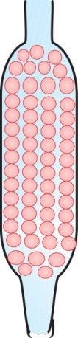
- Potassium chloride and ammonium chloride
- Common salt, water and sand
- Kerosene oil, water and salt

Which of the tubes in Fig. 2. 1 (a) and (b) will be more effective as a condenser in the distillation apparatus?

12. Salt can be recovered from its solution by evaporation.
Suggest some other technique for the same?
The ‘sea-water’ can be classified as a homogeneous

as well as heterogeneous mixture. Comment.
14. While diluting a solution of salt in water, a student by

mistake added acetone (boiling point 56°C). What technique can be
employed to get back the acetone? Justify your choice.

zs.
What would you observe when

a saturated solution of potassium chloride prepared at 60°C is allowed
to cool to room temperature.
- an aqueous sugar solution is heated to dryness.
- a mixture of iron filings and sulphur powder is heated strongly.

16. Explain why particles of a colloidal solution do not settle down when left undisturbed, while in the case of a suspension they do.
Smoke and fog both are aerosols. In what way are they different?
- Classify the following as physical or chemical properties
  - The composition of a sample of steel is: 98% iron, 1.5% carbon and 0.5% other elements.
  - Zinc dissolves in hydrochloric acid with the evolution of hydrogen gas.
  - Metallic sodium is soft enough to be cut with a knife.
  - Most metal oxides form alkalis on interacting with water.

- The teacher instructed three students ‘A’, ‘B’ and ‘C’ respectively to prepare a 50% (mass by volume) solution of sodium hydroxide (NaOH). ‘A’ dissolved 50g of NaOH in 100 mL of water, ‘B’ dissolved 5og of NaOH in 1009 of water while ‘C’ dissolved 50g of NaOH in water to make 100 mL of solution. Which one of them has made the desired solution and why?
2O. Name the process associated with the following
  - Dry ice is kept at room temperature and at one atmospheric pressure.
  - A drop of ink placed on the surface of water contained in a glass spreads throughout the water.
  - A potassium permanganate crystal is in a beaker and water is poured into the beaker with stirring.
  - A acetone bottle is left open and the bottle becomes empty.
  - Milk is churned to separate cream from it.
(1) Settling of sand when a mixture of sand and water is left undisturbed for some time.
(g) Fine beam of light entering through a small hole in a dark room, illuminates the particles in its paths.
2L You are given two samples of water labelled as ‘A’ and ‘B’. Sample ‘A’ boils at l00°C and sample ‘B’ boils at 102°C. Which sample of water will not freeze at 0°C? Comment.
- What are the favourable qualities given to gold when it is alloyed with copper or silver for the purpose of making ornaments?
- An element is sonorous and highly ductile. Under which category would you classify this element? What other characteristics do you expect the element to possess?
- Give an example each for the mixture having the following characteristics. Suggest a suitable method to separate the components of these mixtures
  - A volatile and a non-volatile component.
  - Two volatile components with appreciable difference in boiling points.
  - Two immiscible liquids.
  - One of the components changes directly from solid to gaseous state.
  - Two or more coloured constituents soluble in some solvent.
- Fill in the blanks
  - A colloid is a mixture and its components can be separated by the technique known as
  - Ice, water and water vapour look different and display different properties but they are the same.
  - A mixture of chloroform and water taken in a separating funnel is mixed and left undisturbed for some time. The upper layer in the separating funnel will be of and the lower layer will be that of
  - A mixture of two or more miscible liquids, for which the difference in the boiling points is less than 25 K can be separated by the process called

  - When light is passed through water containing a few drops of milk, it shows a bluish tinge. This is due to the of light by milk and the phenomenon is called . This indicates that milk is a solution.
- Sucrose (sugar) crystals obtained from sugarcane and beetroot are mixed together. Will it be a pure substance or a mixture? Give reasons for the same.
2T. Give some examples of Tyndall effect observed in your surroundings?
- Can we separate alcohol dissolved in water by using a separating funnel? If yes, then describe the procedure.
If not, explain.
- On heating calcium carbonate gets converted into calcium oxide and carbon
dioxide.
  - Is this a physical or a chemical change?
  - Can you prepare one acidic and one basic solution by using the products formed in the above process? If so, write the chemical equation involved.
- Non metals are usually poor conductors of heat and electricity. They are non-lustrous, non-sonorous, non-malleable and are coloured.
  - Name a lustrous non-metal.
  - Name a non-metal which exists as a liquid at room temperature.
  - The allotropic form of a non-metal is a good conductor of electricity. Name the allotrope.
  - Name a non-metal which is known to form the largest number of compounds.
  - Name a non-metal other than carbon which shows allotropy.
  - Name a non-metal which is required for combustion.
Classify the substances given in Fig. 2.2 into elements and compounds
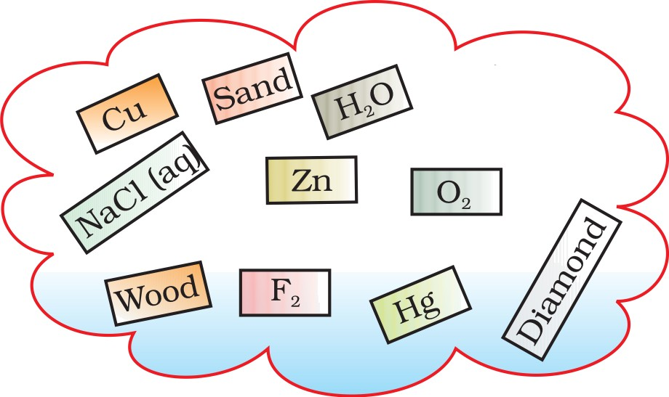

- Which of the following are not compounds?
  - Chlorine gas
  - Potassium chloride
  - Iron
  - Iron sulphide
  - Aluminium
  - Iodine
  - Carbon
  - Carbon monoxide
  - Sulphur powder

Long Answer Questions

Fractional distillation is suitable for separation of miscible liquids with a boiling point difference of about 25 K or less. What part of fractional distillation apparatus makes it efficient and possess an advantage over a simple distillation process. Explain using a diagram.
34. (a) Under which category of mixtures will you classify alloys and why?
- A solution is always a liquid. Comment.
- Can a solution be heterogeneous?

as.
Iron filings and sulphur were mixed together and divided into two parts, ‘A’ and ‘B’. Part ‘A’ was heated strongly while Part ‘B’ was not heated. Dilute hydrochloric acid was added to both the Parts and evolution of gas was seen in both the cases. How will you identify the gases evolved?

- A child wanted to separate the mixture of dyes constituting a sample of ink. He marked a line by the ink on the filter paper and placed the filter paper in a glass containing water as shown in Fig.2.3. The filter paper was removed when the water moved near the top of the filter paper.
  - What would you expect to see, if the ink contains three different coloured components?
  - Name the technique used by the child.
  - Suggest one more application of this technique.
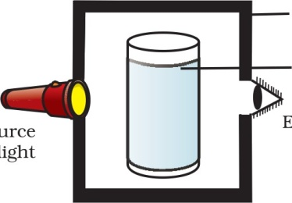
A group of students took an old shoe box and covered it with a black paper from all sides. They Pixed a source of light (a torch) at one end of the box by making a hole in it

Glass rod Paper clips

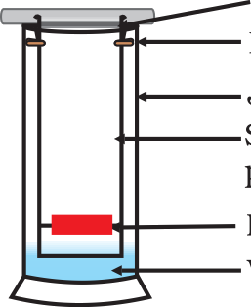Strip of filter paper
Ink Water

Shoe box Glass tumbler
containing sample

and made another hole on the other side to view the light. They placed a milk sample contained in a beaker/tumbler in the box as shown in the Fig.2.4. They were amazed to see that milk taken in the tumbler was

Source of light
Eye

illuminated. They tried the same activity by taking a salt solution but found that light simply passed through it?
    - Explain why the milk sample was illuminated. Name the phenomenon involved.
    - Same results were not observed with a salt solution. Explain.
    - Can you suggest two more solutions which would show the same effect as shown by the milk solution?
- Classify each of the following, as a physical or a chemical change. Give

reasons.
  - Drying of a shirt in the sun.
  - Rising of hot air over a radiator.
  - Burning of kerosene in a lantern.
  - Change in the colour of black tea on adding lemon juice to it.
  - Churning of milk cream to get butter.
- During an experiment the students were asked to prepare a 10% (Mass/Mass) solution of sugar in water. Ramesh dissolved log of sugar in 1009 of water while Sarika prepared it by dissolving 109 of sugar in water to make 1009 of the solution.
  - Are the two solutions of the same concentration
  - Compare the mass % of the two solutions.
- You are provided with a mixture containing sand, iron filings, ammonium chloride and sodium chloride. Describe the procedures you would use to separate these constituents from the mixture?
- Arun has prepared 0.01% (by mass) solution of sodium chloride in water. Which of the following correctly represents the composition of the solutions?
  - 1.00 g of NaC1 + 1009 of water
  - 0. llg of NaC1 + 100g of water
  - 0.01 g of NaC1 + 99.99g of water
  - 0. 10 g of NaCl + 99.90g of water
- Calculate the mass of sodium sulphate required to prepare its 20% (mass percent) solution in 100g of water?

Class-IX Holiday Homework Science-Physics
1. An athlete completes one round of a circular track of diameter 400 m in 80 s. What will be the distance covered and the displacement at the end of 4 minutes 40 s?
2. Joseph jogs from one end A to the other end B of a straight 500 m road in 4 minutes 50 seconds and then turns around and jogs 300 m back to point C in another 3 minute. What are Joseph’s average speeds and velocities in jogging (a) from A to B and (b) from A to C?
3. Abdul, while driving to school, computes the average speed for his trip to be 30 km/h. On his return trip along the same route, there is less traffic and the average speed is 40 km /h. What is the average speed for Abdul’s trip?
4. A motorboat starting from rest on a lake accelerates in a straight line at a constant rate of 3.0 m/s² for 8.0 s. How far does the boat travel during this time?
5. A driver of a car travelling at 52 km /h applies the brakes and accelerates uniformly in the opposite direction. The car stops in 5 s. Another driver going at 3 km/h in another car applies his brakes slowly and stops in 10 s. On the same graph paper, plot the speed versus time graphs for the two cars. Which of the two cars travelled farther after the brakes were applied?
6.A ball is gently dropped from a height of 20 m. If its velocity increases uniformly at the rate of 10 m /s², with what velocity will it strike the ground? After what time will it strike the ground?
7. State which of the following situations are possible and give an example for each of these: (a) an object with a constant acceleration but with zero velocity (b) an object moving in a certain direction with an acceleration in the perpendicular direction.
8. An artificial satellite is moving in a circular orbit of radius 82250 km. Calculate its speed if it takes 24 hours to revolve around the earth.
9.The brakes applied to a car produce an acceleration of 6 m/s² in the opposite direction to the motion. If the car takes 2s to stop after the application of brakes, calculate the distance it travels during this time.
10.A train starting from rest attains a velocity of 72 km h–1 in 5 minutes. Assuming that the acceleration is uniform, find (i) the acceleration and (ii) the distance travelled by the train for attaining this velocity

कक्षा – नवीीं
–
सत्र – 2020-21
नोट- गृह कार्य की एक अलग से पतली कॉपी बनाकर उस पर ललखना है।
1. लनम्नललखखत उपसगो से पाांच पाांच शब्द बनाइर्े।

बे, बद, दुर, कु, सु, लनर, अव
2. लनम्नललखखत प्रत्यर्ोां से पाांच पाांच शब्द बनाइर्े।

इक, ईर्, आलू, ईला, ऊ, अक्कड़, आकू
3. अपने प्राचार्य महोदर् को शुल्क माफ़ी के ललए एक प्रार्यना पत्र ललखखए।

4. कोरोना महामारी के लवषर् में एक अनुच्छेद ललखखए।

5. कबीर के लकन्ही चार दोहो एवां रसखान के दो सवैर्ोां को कांठस्र् कीलिर्े।

6. अब तक पढ़ार्े गए सभी पाठोां को समलिर्े एवां लकर्े गए कार्य (वकयशीट) को र्ाद कीलिर्े।

CLASS –IX
SUBJECT - MATHS
1. Represent the following on number line

√2, √3, √5, √7
2. Represent the following in form of p/q
3.63, 0.6, 483.57, 38.23
3. Solve any Ten question relating to rationalize the denominator.
4. Write all algebraic identities involved in chapter 2 (Polynomial) and also learn them seriously.
5. Solve five questions relating to each identity.
6. Practice seriously & attentively all worksheet shared.

SUMMER VACATION
CLASS 9
- A. ASSIGNMENT

Write the answers of the following questions
● Short answer type questions

1.what is multiple cropping?
बहुविध फसल क्या होता है?
2. Describe two non farm activities in the village Palampur?
पालमपुर गाांि में 2 गैर कृवि क्रियाओां का िर्णन करें
3. Discuss about farm labourers in the village Palampur?
पालमपुर गाांि में खेतों में काम करने िाले श्रममकों की िर्णन करें?
4. Name the countries which are larger than India by size?
उन देशों के नाम मलखे जो भारत से क्षेत्रफल में बडे हैं?
5. what is the importance of standard Meridian line of India?
भारत की मानक समय रेखा का क्या महत्ि है?
6. What are tectonic plates?
टेक्टोननक प्लेट क्या होती है?
7. distinguish between Bhangar and Khadar?
बाांगर तथा खादर में अांतर स्पष्ट करें?
8. Distinguish between Western Ghats and Eastern Ghats?
पश्चिमी घाट तथा पूिी घाट में अांतर स्पष्ट करें?
9. Describe the brief description of Himalayas?
हहमालय का सांक्षक्षप्त िर्णन करें
10. explain any three features of Deccan Plateau
दक्कन के पठार की तीन विशेिताएां बताएां?
11. explain any three features of Northern Plains?
उत्तर के मैदानों की तीन विशेिताएां बताएां?
12. Name any three main social classes of 18th century France?
18िीां सदी के फ्ाांस में समाज का िगीकरर् क्रकस प्रकार क्रकया गया था?
13. How many taxes applicable on the third estate?
तृतीय स्टेट पर क्रकतने तरह के टैक्स लगाए जाते थे?
14. what led to the fall of the Bastille?
बास्तील का क्रकला क्यों टूटा?
15. explain the island groups of India?
भारत के दो समूहों की व्याख्या करें?
LONG ANSWER TYPE QUESTIONS
1.What were the main causes of the French revolution of 1789?
1789 की फ्ाांसीसी िाांनत के मुख्य कारर् क्या थे?
2. Describe the event of 14 July 1789?
14 जुलाई 1789 की घटना का िर्णन करें?
3. What is the longitudinal and latitudinal extension of India what is its importance?
भारत का अक्षाांशीय तथा देशाांतरीय विस्तार क्रकतना है तथा इसकी क्या विशेिता है?
4. Explain how the Himalayas act as a boon for India?
हहमालय क्रकस तरह भारत के मलए एक िरदान का काम करता है?
5. describe the Indian desert?
भारतीय मरुस्थल की व्याख्या करें?
6. describe the coastal plains?
तटीय मैदानों की व्याख्या करें?
7. Which is the oldest landmass in India write any five features?
भारत का सबसे पुराना भू भाग कौन सा है उसके पाांि विशेिताएां मलखें?
8. Describe any three divisions of the Himalaya on the basis of regions from west to east?
हहमालय की पश्चिम से पूिण की ओर बढ़ते हुए उसकी बकरिगीकरर् करें?
9. The Indian ocean named after our country India explain?
हहांद महासागर का नाम हमारा देश भारत के नाम पर पडा व्याख्या करें?
10. What is the role of philosophers in the French Revolution?
फ्ाांसीसी िाांनत में दाशणननकों की क्या भूममका थी?
11. Which causes led to subsistence crisis in France during the old regime?
पुराने राजव्यिस्था में फ्ाांस में क्रकस कारर् से ननिाणह का सांकट पैदा हो गया?
12. describe the dairy activity in the village Palampur?
पालमपुर गाांि में डेरी क्रिया का िर्णन करें?
13. How small and large farmers arrange capital for farming activity?
छोटे तथा बडे क्रकसान क्रकस तरह खेती करने के मलए पूांजी जुटा ते हैं?
14. what is physical capital? what are its different types?
भौनतक पूांजी क्या है तथा इसके विमभन्न प्रकार कौन-कौन से हैं?
15. Describe non farming activities in Palampur?
पालमपुर में कौन-कौन से गैर कृवि क्रियाएां की जाते हैं?
B. MAP WORK
Locate the following on the map of India

1. Tropic of Cancer ककण रेखा
2. Standard Meridian of India भारत की मानक समय रेखा
3. The Aravali mountain range अरािली पिणत श्रांखला
4. The vindhyachal mountain range विां ध्यािल पिणत श्रृ ांखला
5. The satpura mountain सतपुडा पिणत
6. Western Ghat and Eastern Ghat पूिी तथा पश्चिमी घाट
7. Mount Everest
8. Islands of India भारत के द्िीप समूह
9. Anaimudi अनाईमुडी
10. Nilagiri नीलगगरी

C.Make 10 multiple choice questions from each chapter
- A. The French revolution फ्ाांसीसी िाांनत
- B. India size and location भारत आकार और श्स्थनत
- C. Physical features of India भारत का भौनतक स्िरूप

