KENDRIYA VIDYALAYA KASHIPUR
HOLIDAY HOMEWORK (SUMMER VACATIONS 2020-2021) Sub: Computer Science
- Solve all the worksheets which I have shared.
- Prepare notes of “Networking” chapter from the pdf.
- Solve the following Questions of CBSE Question paper (Question No.1):
1.Rewrite the following code in Python after removing all syntax error(s). Underline each correction done in the code.
"HELLO"=String
for I in range (0,len(String)–1)
if String[I]=>"M":
print (String[I],"*”)
else:
print (String [I-1])

2. Find and write the output of the following Python code :
Str1="EXAM2018"
Str2=""
I=0
while I<len(Str1):
if Str1[I]>="A" and Str1[I]<="M":
Str2=Str2+Str1[I+1]
elif Str1[I]>="0" and Str1[I]<="9":
Str2=Str2+ (Str1[I-1])
else:
Str2=Str2+"*"
I=I+1
print (Str2)

3. Find and write the output of the following Python code :
def Alter(P=15,Q=10):
P=P*Q
Q=P/Q
print(P,"#",Q)
return Q
A=100
B=200
A=Alter(A,B)
print( A,"$",B )
B=Alter(B)
print( A,"$",B )
A=Alter(A)
print( A,"$",B )

4. What possible output(s) are expected to be displayed on screen at the time of execution of the program from the following Python code ? Also specify the minimum values that can be assigned to each of the variables BEGIN and LAST.
import random
VAL=[80,70,60,50,40,30,20,10]
Start=random.randint(1,3)
End=random.randint(Start,4)
for I in range(Start,End+1):
print (VAL[I],"*",)  (i) 40 * 30 * 20 * 10 * | (ii) 70 * 60 * 50 * 40 * 30 *
(iii) 50 * 40 * 30 * | (iv) 60 * 50 * 40 * 30 *
5.Rewrite the following code in python after removing all syntax error(s). Underline each correction done in the code.
250 = Number
while Number<=1000:
if Number=>750:
print( Number)
Number=Number+100
else
print Number*2
Number=Number+50

6.Find and write the output of the following python code :
Msg1="WeLcOME"
Msg2="GUeSTs"
Msg3=""
for I in range(0,len(Msg2)+1):
if Msg1[I]>="A" and Msg1[I]<="M":
Msg3=Msg3+Msg1[I]
elif Msg1[I]>="N" and Msg1[I]<="Z":
Msg3=Msg3+Msg2[I]
else:
Msg3=Msg3+"*"
print( Msg3)

7.Find and write the output of the following python code : 3
def Changer(P,Q=10):
P=P/Q
Q=P%Q
print( P,"#",Q)
return P
A=200
B=20
A=Changer(A,B)
print (A,"$",B)
B=Changer(B)
print (A,"$",B)
A=Changer(A)
print (A,"$",B)

8.What possible output(s) are expected to be displayed on screen at the time of execution of the program from the following code ? Also specify the minimum values that can be assigned to each of the variables BEGIN and LAST.
import random
VALUES=[10,20,30,40,50,60,70,80]
BEGIN=random.randint(1,3)
LAST=random.randint(BEGIN,4)
for I in range(BEGIN,LAST+1):
print (VALUES[I],"-",)
(i) 30 - 40 - 50 - (ii) 10 - 20 - 30 - 40 -
(iii) 30 - 40 - 50 - 60 - (iv) 30 - 40 - 50 - 60 - 70 –

9.Rewrite the following code in Python after removing all syntax error(s). Underline each correction done in the code.
NUM1=1234
1=DAY1
for C in range[1,4]: NUM+C=NUM1 DAY1=DAY1+2
print ( C )
print (NUM1:DAY1)

15.Find and write the output of the following Python code :
L1 = [100,900,300,400,500]
START = 1
SUM = 0
for C in range (START,4):
SUM = SUM + L1[C]
print( C,":",SUM)
SUM = SUM + L1[0]*10
print (SUM)

10. What are the possible outcome(s) executed from the following code ? Also specify the maximum and minimum values that can be assigned to variable N.
import random
PLAY=[40,50,10,20]"EAST","WEST","NORTH","SOUTH";
ROUND=random.randint(2,3)
for J in range(ROUND,1,–1):
print (PLAY[J],”:”)  (i) 20:10: | (ii) 20:10:50:
(iii) 20: | (iv) 40:50:20:
11.Rewrite the following code in python after removing all syntax error(s). Underline each correction done in the code.
for Name in [Amar,Shveta,Parag]
IF Name[0]=’S’:
print(Name)

12.Find and write the output of the following python code :
Numbers = [9,18,27,36]
for Num in Numbers:
for N in range(1, Num%8): print(N,”#”,end=””)
print()
13. What are the possible outcome(s) executed from the following code ? Also specify the maximum and minimum values that can be assigned to the variable N.
import random
NAV = ["LEFT","FRONT","RIGHT","BACK"]
NUM = random.randint(1,3)
NAVG = ""
for C in range (NUM,1,-1):
NAVG = NAVG+NAV[I]
print (NAVG)  (i) BACKRIGHT | (ii) BACKRIGHTFRONT
(iii) BACK | (iv) LEFTFRONTRIGHT
14. Find and write the output of the following Python code :
Data = ["P",20,"R",10,"S",30]
Times = 0
Alpha = ""
Add = 0
for C in range(1,6,2):
Times = Times + C
Alpha = Alpha + Data[C-1]+"$"
Add = Add + Data[C]
print (Times,Add,Alpha)

15. Find and write the output of the following Python code :
for Name in ['John', 'Garima','Seema','Karan']:
print (Name)
if Name[0]=='S':
break
else:
print( 'Completed!' )
print('Welldone!')
16. Write a Python function to find the Max of three numbers.
17. Write a Python function to sum all the numbers in a list.
Sample List : (8, 2, 3, 0, 7)
Expected Output : 20
18. Write a Python function to multiply all the numbers in a list.
Sample List : (8, 2, 3, -1, 7)
Expected Output : -336
19. Write a Python program to reverse a string.
Sample String : "1234abcd"
Expected Output : "dcba4321"
20. Write a Python function to calculate the factorial of a number (a non-negative integer). The function accepts the number as an argument.

KENDRIYA VIDYALAYA KASHIPUR
HOME ASSIGNMENT FOR SUMMER VACATION
CLASS- 12TH
SUBJECT- ENGLISH
(READING)
- READING OF FOLLOWING LESSONS AND SOLVING COMPREHENSION EXERCISES GIVEN ALONG WITH THE TEXT:
- Last Lesson (Flamingo)
- Lost Spring (Flamingo)
- My Mother At Sixty Six (Flamingo)
- An Elementary school classroom in a slum (Flamingo)
- Third Level ( vistas)
- Tiger king ( vistas)
NOTE :- All this work must be completed in a Ax4 size fair notebook.
(WRITING)
- WRITE ALL THESE QUESTIONS IN PROPER FORMAT AND WORD LIMIT(120 TO 150 WORDS):
- Write a letter to the editor of a national daily, highlighting the problem of CORONA and unhygienic public places and suggesting practical ways to ensure public sanitation to save people from diseases.
- You are Neha/Nihal, computer in-charge of Army Public School, New Delhi. Your school wishes to buy 20 computers and computer accessories from Apple Inc., Nehru Place, New Delhi. Draft a letter placing an order for the same.(100-150 words)
- You are RAM/RAJNI, 48-drona vihar,kashipur. Draft a classified advertisement, in not more than 50 words to sell your house giving all necessary detail.
- You are Sonali, cultural captain,Army Public School,Haldwani. Writ a notice for the school noticeboard informing the students about RANGOLI COMPETETION in the school.
NOTE :- 1. All this work must be completed in an Ax4 size fair notebook.
- For any help please visit youtube channel-htts://www.youtube.com/channel/UCILNx9AvR1KbE6_tuyRPMYg
Or www.yschandel.blogspot.com

RELATIONS & FUNCTIONS

VER SHORT ANSWER TYPE QUESTIONS

- If A =$\left\{1,3,5,7\right\}$ and B= $\left\{1,2,3,4,5,6,7,8\right\}$ then the number of one to one function from A into B is
- 1340 b) 1860 c) 1430 d) 1680

- If f($x$)= $\left|x\right| and g\left(x\right)$= $\left|5x-2\right|$ then (g$οf)$(-3) is
- 4 b) 6 c) 13 d) none of these.

- The relation R on the set A =$\left\{1,2,3\right\}$ given by R = $\left\{\left(1,1\right),\left(1,2\right),\left(2,2\right),\left(2,3\right),(3,3)\right\}$ is
- Reflexive b) Symmetric c) Transitive d) Equivalence
4. Given set A = $\left\{1,2,3\right\}$ and a relation R = $\left\{\left(1,2\right), (2,1)\right\}$ will be
a) reflexive if (1,1) is added b) symmetric if (2,3) is added
c) transitive if (1,1) is added d) symmetric if (3,2) is added

5. If R is an equivalence relation on A =$\left\{xϵ Z :0≤x≤15\right\}$ given by
R = $\left\{\left(a,b\right): \left|a-b\right| is a multiple of 5\right\}$ then the set of elements related to 6 are
$a) \left\{0,11\right\}$b) $\left\{6,15\right\}$ c)$\left\{6,11\right\}$ d) $\left\{0, 6\right\}$

6. Let A = $\left\{1,2,3,4\right\}$ and B = $\left\{a,b,c\right\}$.The number of one to one functions from A to B are
…………………………..
7. If $f\left(x\right)$= 27$x^{3}$ and $g\left(x\right)=x^{1/3}$ then $(gοf)(x)$ is …………………..
8. If f: R $→R$be such that $\left(fο f\right)\left(x\right)=x∀ x∈R$then the inverse of $f$ is …………………

9. Given triangles with sides $T_{1}$ : 3 , 4 , 5 ; ${ T}_{2}$ : 5, 12, 13 ; $T_{3}$ : 6, 8 ,10 ; $T_{4}$ : 4 , 7 , 9 and
f a relation R in the set of triangles defined as $R= \left\{{(∆}_{1} , ∆_{2 }) : ∆_{1 }is similar to ∆_{2}\right\}$ .
then triangle …………………………..is related to …………………………….

10. Let R be a relation on the set L of lines defined by
$R=\left\{\left(l_{1 }, l_{2}\right): l_{1 }is perpendicular to l_{2}\right\}$ . The relation R is …………………………
(reflexive/ symmetric/ transitive) relation.

11. Let R be the equivalence relation in the set $A=\left\{0,1,2,3,4,5\right\}$ given by
$R=\left\{\left(a,b\right):2 divides (a-b)\right\}$. Write the equivalence class$\left[0\right]$.

12. Let $f :R →R$be defined by $f\left(x\right)=x^{2}$ + 1. Find $f^{-1}$(37$)$.

13. If the function $f :R →R$ defined by $f\left(x\right)=3x-4$ is invertible then find$f^{-1}(x)$.

14. If n(A) = 3 and n(B) = 4 then find the number of injective functions from A to B.

15. If f: R→ R defined by $f\left(x\right)= {(3-x^{3})}^{1/3}$ then find $\left(fοf\right)\left(x\right).$
16. If $f\left(x\right)$= ${8x}^{3}$ and $g\left(x\right)=x^{1/3}$ then $(gοf)(x)$ is
(a) x (b)2x (c) x/2 (d)3x²
17.If f(x) =x² ,g(x) =tanx ,h(x) =log x then [h0 (g0f)]$(\sqrt{\frac{π}{4}}$ ) is
(a) 0 (b) 1 (c) 1/x (d) $\frac{1}{2}$log$\frac{π}{4}$
18 f:R→ R , f(x) =cos x is

(a) one to one and into (b)one to one and onto
(c) Many to one and onto (d)Many to one and into

19. If

A = {1,2,3} Let
R={(1,1),(2,2),(3,3),(1,2),(2,1),(2,3),(3,2) },Then R is:

(a) Reflexive, symmetric but not transitive (b)symmetric, transitive but not reflexive

(c)Reflexive and transitive but not symmetric (d)an equivalence relation

20.Let R be a relation defined on Z byaRb⇔ a≥b,Then R is:

(a) Symmetric, transitive but not reflexive (b)Reflexive, symmetric but not transitive

- Reflexive and transitive but not symmetric (d)an equivalence relation

21.Let R be a relation defined on Z as follows:(a,b)∈ R⇔ a2+ b2 = 25,ThendomainofRis:

(a) {3,4,5}
(b){0,3,4,5}
(c){0,± 3,± 4,± 5}

- None of these

22. The relation R defined on the set

A={1,2,3,4,5} by
R={(a,b):a2− b2
< 16}is given by:

(a)
{(1,1),(2,1),(3,1),(4,1),(2,3)}
(b){(2,2),(3,2),(4,2),(2,4)}

(c) {(3,3),(4,3),(5,4),(3,4)}

(d)none of these

23.Let R be a relation defined on Z as follows:( x,y)∈R⇔

x− y

≤ 1.ThenR is:

- Reflexive and transitive (b)Reflexive and symmetric

(c)Symmetric and transitive (d)an equivalence relation

24.Let
A={1,2,3} ,B= {1,4,6,9} and R is a relation from A to B define by ‘x is greater than y’.

Then range of R is given by:
(a){1,4,6,9} (b) {4,6,9} (c) {1} (d) none of these

25. A relation R is defined from {2,3,4,5} to{3,6,7,10}by
Then the domain of R is given by:
xRy⇔ x is relatively prime to y.

(a){2,3,5}
(b){3,5}
(c){2,3,4}
(d){2,3,4,5}

26.In the set Z of integers, which of the following relation R is not an equivalence relation?

(a)

(c)
xRy: if x≤ y

xRy:if x− y is an even integer
(b)

(d)
xRy : if x= y
xRy :if x−y is a multiple of 5

27.Let

f:R→ R and g:R→ R be defined by
f( x) = 2x2 + 3x+ 5and g( x) = 4x−5,then ( fog)(0) is:

(a)20 (b)25 (c)40 (d)10

28. Which of the following functions from Z to itself are bijections ?

(a)
f( x) = x3

(b)
f( x) = x+ 2

(c)
f( x) = 2x+1

(d)
f( x) = x2+ x

29.If the function
f:[2,∞)→ B defined by
f( x) = x2− 4x+ 5 is a bijection, then B is:

(a)R (b)[1,∞)
- [4,∞)
- [5,∞)

30 Let
f( x) = x2 and g( x) = 2x. Then the solution set of the equation
fog( x) = gof( x) is:

(a)R (b){0}
- {0,2} (d) None of these

LONG ANSWER TYPE QUESTIONS
- Show that the relation R in the set A = {1, 2, 3, 4, 5} given by R = {(a,b): |a − b| is even}, is an equivalence relation. Show that all the elements of {1, 3, 5} are related to each other and all the elements of {2, 4} are related to each other. But no element of {1, 3, 5} is related to any element of 2, 4}.
- Show that each of the relation R in the set A = {x ∈ Z: 0 ≤ x ≤ 12}, given by
(i) R = {(a, b) : |a – b| is a multiple of 4} (ii) R = {(a, b) : a = b} is an equivalence relation. Find the set of all elements related to 1 in each case.
- Show that the relation R defined in the set A of all triangles as R = {(T_{1, T2): T1 is} similar to T2}, is equivalence relation. Consider three right angle triangles T1 with sides 3, 4, 5, T2 with sides 5, 12, 13 and T3 with sides 6, 8, 10. Which triangles among T1, T2 and T3 are related?
- Show that the relation R defined in the set A of all polygons as R = {(P1, P2): P1 and P2 have same number of sides}, is an equivalence relation. What is the set _{of} all elements in A related to the right angle triangle T with sides 3, 4 and 5?
- Let L be the set of all lines in XY plane and R be the relation in L defined as R = {( L1,L2): L1 is parallel to L2}. Show that R is an equivalence relation. Find the set of all lines related to the line y = 2x + 4.

- Let A = R − {3} and B = R − {1}. Consider the function f: A → B defined by (x) = (x−2 x−3). Is f one-one and onto? Justify your answer.
- Consider f: R → R given by f(x) = 4x + 3. Show that f is invertible. Find the inverse of f.
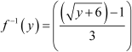
- Consider f: R₊ → [4, ∞) given by f(x) = x² + 4. Show that f is invertible with the inverse f⁻¹ of given f byf⁻¹(y) = √y − 4, where R₊ is the set of all non- negative real numbers.
- Consider f: R₊ → [−5, ∞) given by f(x) = 9x² + 6x − 5. Show that f is invertible with

10. Show that the relation R in the set Z of integers given byR = {(a, b) : 2 divides a – b}is an equivalence relation.
11. . Let f: W → W be defined as f(n) = n − 1, if is odd and f(n) = n + 1, if n is even. Show
that f is invertible. Find the inverse of f. Here, W is the set of all whole numbers.
12. Show that the function $f:$ $R→\{x∈R , -1<x<1\}$ defined by $f\left(x\right)= \frac{x}{1+\left|x\right|}$ , $x∈R$
is one one and onto

13. Let A = {– 1, 0, 1, 2}, B = {– 4, – 2, 0, 2} and f, g : A →B be functions defined by
f(x) =x²–x, x∈A and g(x) = , x∈A. Are f and g equal? Justify your answer.

INVERSE TRIGONOMETRIC FUNCTIONS

VERY SHORT ANSWER TYPE QUESTIONS
- Find the value of Sin⁻¹ sin ($\frac{4π}{5}$)
- $Find the value of \tan^{-1}{2}+\tan^{-1}{3}$
- $If \tan^{-1}{x= \frac{π}{10} for some x∈R then the value of \cot^{-1}{x is }}$
- $\frac{2π}{5}$ b) $\frac{π}{5}$ c)$\frac{3π}{5}$ d) $\frac{10}{π}$
- The domain of $\sin^{-1}({3x)} is$
$$a) \left[-1,1\right] b) \left[0,1\right] c) \left[\frac{-1}{3},\frac{1}{3}\right] d) \left[-3,3\right]$$

- $The value of \tan^{-1}{x}+\tan^{-1}{(\frac{1}{x}}) , x>0 is……………………..$
- $The value of \sec^{2}\tan^{-1}{4+ {cosec}^{2}\cot^{-1}{3 is…………….. }}$
7 If $\sin^{-1}{x }+ \sin^{-1}{y= π } then 4x-5y is……………..$
8 Find the value of $\cos^{-1}{\cos{(}}\frac{2π}{3})+\sin^{-1}{\cos{(}}\frac{2π}{3})$
9 If $θ= \sin^{-1}{sin⁡({-600}^{0}}) then θ is$
- $\frac{2π }{3}$b) $\frac{π}{3}$ c)$\frac{-2π}{5}$ d) $\frac{π}{2}$
10 Write the following in simplest form
$\tan^{-1}({\frac{8x}{1+20x^{2}} )}$
11.Write the following in simplest form
Cos⁻¹( 1-x² /1+x²)
12.Find the value of $\sin^{-1}{\sin{(}}\frac{π}{3})+\cos^{-1}{\cos{(}}\frac{2π}{3})$
13.Find the principal value of cos⁻¹ ($\frac{-1}{2}$)
14 Find the value of 2cos(2$\sin^{-1}$1)
15. Fill in the blank : $\sin^{-1}\frac{8}{17}$ = Cos⁻¹ ……..
.16 $\tan^{-1}{(\frac{1}{11})}$+$\tan^{-1}{(\frac{2}{11})}$= ………..
17. If $\sin^{-1}{x -}\cos^{-1}{x= π /6} then x is equal to……………..$
18.The value of $\cos^{-1}{\cos{(}}\frac{13π}{6}$) $is equal to……………..$
19.The value of tan [2tan⁻¹(1/5) -$\frac{π}{4}$ ] $is equal$ to ………..
20.The value of cos[$\tan^{-1}$(3/4)] $is equal$ to ………..

MATRICES

MULTIPLE CHOICE QUESTIONS
Choose and write the correct option in the following questions
- For what value of x, the matrix$\left[\begin{matrix}5-x & x+1 \\ 2 & 4\end{matrix}\right]$is singular?A matrix A is both symmetric and skew symmetric if A is
- Null matrix (b) unit matrix (c) row matrix (d) none of these
- If A and B are invertible matrix then (AB)⁻¹ = ..........
- A⁻¹B⁻¹ (b) AB (c) B⁻¹A⁻¹ (d) none of these
- If A be any invertible matrix such that A³ = I then A⁻¹ = ........
- I (b) A² (c) A³ (d) A⁴
- If A is a matrix of order 3x3 , then (A²)⁻¹ = (A⁻¹ ) ² -
- True (b) false (c)none of these
- If A is any invertible matrix then A is
- square matrix (b) non singular matrix (c) both (d) none of these
- If A is any skew symmetric matrix then $A'$ =
- A (b) - A (c) A² (d) none of these
- Let A be a square matrix of order 3x3 then| kA| = ......
- k |A| (b) k²|A| (c) k³|A| (d) 3k|A|

- If$\left[\begin{matrix} x+3y & y \\ 7-x & 4 \end{matrix}\right]=\left[\begin{matrix}4 & -1 \\ 0 & 4\end{matrix}\right]$, find the values of $x and y.$
- If $\left[\begin{matrix}3x+y & -y \\ 2y-x & 3\end{matrix}\right]=\left[\begin{matrix} 1 & 2 \\ -5 & 3\end{matrix}\right]$, find the value of $x.$
- If $A=\left[\begin{matrix} 2 & 3 \\ 5 & -2\end{matrix}\right]$, Write $A^{-1}$ in terms of A.
- A matrix $A=\left[\begin{matrix} 2 & -2 \\ -2 & 2\end{matrix}\right]$and $A^{2}=pA$, then write the value of p.
- If a matrix has 6 elements, write all possible orders it can have.
- Write the order of the product matrix: $\left[\begin{matrix}1 & 2 & 1\end{matrix}\right]\left[\begin{matrix}2 \\ 4 \\ 2\end{matrix}\right] .$
- If A and B are symmetric matrices, prove that AB – BA is a skew symmetric matrix.
- Show that all the elements on the main diagonal of a skew symmetric matrix are zero.

- Find the value of x + y from the following equation:
$2\left[\begin{matrix}x & 5 \\ 7 & y-3\end{matrix}\right]+\left[\begin{matrix}3 & -4 \\ 1 & 2\end{matrix}\right]=\left[\begin{matrix}7 & 6 \\ 15 & 14\end{matrix}\right]$
- If ${ A}^{T}=\left[\begin{matrix}3 & 4 \\ -1 & 2 \\ 0 & 1\end{matrix}\right]$and$B=\left[\begin{matrix}-1 & 2 & 1 \\ 1 & 2 & 3 \end{matrix}\right]$ ,find$A^{T}-B^{T}$ .
- If $A^{'}=\left[\begin{matrix}-2 & 3 \\ 1 & 2\end{matrix}\right]$and $B=\left[\begin{matrix}-1 & 0 \\ 1 & 2\end{matrix}\right]$ , then find ${\left(A+2B\right)}^{'}$.
- If $\left[\begin{matrix}a-b & 2a+c \\ 2a-b & 3c+d \end{matrix}\right]=\left[\begin{matrix}-1 & 5 \\ 0 & 13 \end{matrix}\right]$, find the value of $a.$
- If$\left[\begin{matrix} 9 & -1 & 4 \\ -2 & 1 & 3\end{matrix}\right]=A+\left[\begin{matrix}1 & 2 & -1 \\ 0 & 4 & 9\end{matrix}\right]$, then find the matrix $A.$
- If $\left[\begin{matrix}x-y & z \\ 2x-y & w\end{matrix}\right]=\left[\begin{matrix}-1 & 4 \\ 0 & 5\end{matrix}\right]$, find the value of$x+y.$

- Write the number of all possible matrices of order $2×2$ with each entry 1,2or 3

- If the matrix$A=\left[\begin{matrix} 0 & a & -3 \\ 2 & 0 & -1 \\ b & 1 & 0\end{matrix}\right]$ is skew symmetric, find the value of a and b.
- Construct a matrix of order $2×2$, whose elements are given by $a_{ij}=\frac{\left|4i-j\right|}{2}$

SHORT ANSWER TYPE QUESTIONS -(2 marks questions)
- If $\left[\begin{matrix}3 & 4 \\ 2 & x\end{matrix}\right]\left[\begin{matrix}x \\ 1\end{matrix}\right] = \left[\begin{matrix}19 \\ 15\end{matrix}\right]$ , find the value of x.
- If $\left(\begin{matrix}2x+y & 3y \\ 0 & 4\end{matrix}\right)={\left(\begin{matrix}6 & 0 \\ 6 & 4\end{matrix}\right)}^{'}$ , then find x and y.
- If the matrix$\left[\begin{matrix}0 & a & 3 \\ 2 & b & -1 \\ c & 1 & 0\end{matrix}\right]$ is skew symmetric, find a + b + c
- The matrix A = $\left[\begin{matrix}1 & 2 & 2 \\ 2 & 1 & 2 \\ 2 & 2 & 1\end{matrix}\right]$ satisfies A² – 4A – 5 I = 0
- Find X, if X +$\left[\begin{matrix}2 & -1 \\ 3 & -1\end{matrix}\right]$ = $\left[\begin{matrix}2 & 4 \\ 5 & 0\end{matrix}\right]$

- If f(x) =$\left[\begin{matrix}\cos{x} & -\sin{x} & 0 \\ \sin{x} & \cos{x} & 0 \\ 0 & 0 & 1\end{matrix}\right]$ , then show that f(x) f(y) = f ( x +y).

- If A = $\left[\begin{matrix}a & b \\ b & a\end{matrix}\right]$ and A² = $\left[\begin{matrix}∝ & β \\ β & α\end{matrix}\right]$ Then prove that α + β = (a + b )².
- If A and B are symmetric matrices of the same order, then prove that AB-BA is skew-symmetric.
- Three shopkeepers A, B, C are using polythene, handmade bags (prepared by prisoners), and newspaper’s envelope as carry bags. it is found that the shopkeepers A, B, C are using (20,30,40) , (30,40,20,) , (40,20,30) polythene , handmade bags and newspapers envelopes respectively. The shopkeepers A, B, C spent Rs.250, Rs.220 & Rs.200 on these carry bags respectively. Formulate a matrix problem.

- Using elementary operation , find the inverse of the matrix A =$\left[\begin{matrix}1 & 1 \\ 4 & 3\end{matrix}\right]$
11. Express the following matrix as the sum of a symmetric matrix and a skew symmetric matrix.
A = $\left[\begin{matrix}1 & 3 & 5 \\ -6 & 8 & 3 \\ 4 & 6 & 5\end{matrix}\right]$
12. Express the following matrix as the sum of a symmetric matrix and a skew symmetric matrix.
A = $\left[\begin{matrix}3 & 2 & 5 \\ 4 & 1 & 3 \\ 0 & 6 & 7\end{matrix}\right]$.
13. Using elementary transformations, find the inverse of the following matrix:
$$\left[\begin{matrix}1 & 2 & -2 \\ -1 & 3 & 0 \\ 0 & -2 & 1\end{matrix}\right]$$
14. Using elementary transformations, find the inverse of the following matrix:
$\left[\begin{matrix}1 & 3 & -2 \\ -3 & 0 & -1 \\ 2 & 1 & 0\end{matrix}\right]$.

RELATIONS & FUNCTIONS

VER SHORT ANSWER TYPE QUESTIONS

- If A =$\left\{1,3,5,7\right\}$ and B= $\left\{1,2,3,4,5,6,7,8\right\}$ then the number of one to one function from A into B is
- 1340 b) 1860 c) 1430 d) 1680

- If f($x$)= $\left|x\right| and g\left(x\right)$= $\left|5x-2\right|$ then (g$οf)$(-3) is
- 4 b) 6 c) 13 d) none of these.

- The relation R on the set A =$\left\{1,2,3\right\}$ given by R = $\left\{\left(1,1\right),\left(1,2\right),\left(2,2\right),\left(2,3\right),(3,3)\right\}$ is
- Reflexive b) Symmetric c) Transitive d) Equivalence
4. Given set A = $\left\{1,2,3\right\}$ and a relation R = $\left\{\left(1,2\right), (2,1)\right\}$ will be
a) reflexive if (1,1) is added b) symmetric if (2,3) is added
c) transitive if (1,1) is added d) symmetric if (3,2) is added

5. If R is an equivalence relation on A =$\left\{xϵ Z :0≤x≤15\right\}$ given by
R = $\left\{\left(a,b\right): \left|a-b\right| is a multiple of 5\right\}$ then the set of elements related to 6 are
$a) \left\{0,11\right\}$b) $\left\{6,15\right\}$ c)$\left\{6,11\right\}$ d) $\left\{0, 6\right\}$

6. Let A = $\left\{1,2,3,4\right\}$ and B = $\left\{a,b,c\right\}$.The number of one to one functions from A to B are
…………………………..
7. If $f\left(x\right)$= 27$x^{3}$ and $g\left(x\right)=x^{1/3}$ then $(gοf)(x)$ is …………………..
8. If f: R $→R$be such that $\left(fο f\right)\left(x\right)=x∀ x∈R$then the inverse of $f$ is …………………

9. Given triangles with sides $T_{1}$ : 3 , 4 , 5 ; ${ T}_{2}$ : 5, 12, 13 ; $T_{3}$ : 6, 8 ,10 ; $T_{4}$ : 4 , 7 , 9 and
f a relation R in the set of triangles defined as $R= \left\{{(∆}_{1} , ∆_{2 }) : ∆_{1 }is similar to ∆_{2}\right\}$ .
then triangle …………………………..is related to …………………………….

10. Let R be a relation on the set L of lines defined by
$R=\left\{\left(l_{1 }, l_{2}\right): l_{1 }is perpendicular to l_{2}\right\}$ . The relation R is …………………………
(reflexive/ symmetric/ transitive) relation.

11. Let R be the equivalence relation in the set $A=\left\{0,1,2,3,4,5\right\}$ given by
$R=\left\{\left(a,b\right):2 divides (a-b)\right\}$. Write the equivalence class$\left[0\right]$.

12. Let $f :R →R$be defined by $f\left(x\right)=x^{2}$ + 1. Find $f^{-1}$(37$)$.

13. If the function $f :R →R$ defined by $f\left(x\right)=3x-4$ is invertible then find$f^{-1}(x)$.

14. If n(A) = 3 and n(B) = 4 then find the number of injective functions from A to B.

15. If f: R→ R defined by $f\left(x\right)= {(3-x^{3})}^{1/3}$ then find $\left(fοf\right)\left(x\right).$
16. If $f\left(x\right)$= ${8x}^{3}$ and $g\left(x\right)=x^{1/3}$ then $(gοf)(x)$ is
(a) x (b)2x (c) x/2 (d)3x²
17.If f(x) =x² ,g(x) =tanx ,h(x) =log x then [h0 (g0f)]$(\sqrt{\frac{π}{4}}$ ) is
(a) 0 (b) 1 (c) 1/x (d) $\frac{1}{2}$log$\frac{π}{4}$
18 f:R→ R , f(x) =cos x is

(a) one to one and into (b)one to one and onto
(c) Many to one and onto (d)Many to one and into

19. If

A = {1,2,3} Let
R={(1,1),(2,2),(3,3),(1,2),(2,1),(2,3),(3,2) },Then R is:

(a) Reflexive, symmetric but not transitive (b)symmetric, transitive but not reflexive

(c)Reflexive and transitive but not symmetric (d)an equivalence relation

20.Let R be a relation defined on Z byaRb⇔ a≥b,Then R is:

(a) Symmetric, transitive but not reflexive (b)Reflexive, symmetric but not transitive

- Reflexive and transitive but not symmetric (d)an equivalence relation

21.Let R be a relation defined on Z as follows:(a,b)∈ R⇔ a2+ b2 = 25,ThendomainofRis:

(a) {3,4,5}
(b){0,3,4,5}
(c){0,± 3,± 4,± 5}

- None of these

22. The relation R defined on the set

A={1,2,3,4,5} by
R={(a,b):a2− b2
< 16}is given by:

(a)
{(1,1),(2,1),(3,1),(4,1),(2,3)}
(b){(2,2),(3,2),(4,2),(2,4)}

(c) {(3,3),(4,3),(5,4),(3,4)}

(d)none of these

23.Let R be a relation defined on Z as follows:( x,y)∈R⇔

x− y

≤ 1.ThenR is:

- Reflexive and transitive (b)Reflexive and symmetric

(c)Symmetric and transitive (d)an equivalence relation

24.Let
A={1,2,3} ,B= {1,4,6,9} and R is a relation from A to B define by ‘x is greater than y’.

Then range of R is given by:
(a){1,4,6,9} (b) {4,6,9} (c) {1} (d) none of these

25. A relation R is defined from {2,3,4,5} to{3,6,7,10}by
Then the domain of R is given by:
xRy⇔ x is relatively prime to y.

(a){2,3,5}
(b){3,5}
(c){2,3,4}
(d){2,3,4,5}

26.In the set Z of integers, which of the following relation R is not an equivalence relation?

(a)

(c)
xRy: if x≤ y

xRy:if x− y is an even integer
(b)

(d)
xRy : if x= y
xRy :if x−y is a multiple of 5

27.Let

f:R→ R and g:R→ R be defined by
f( x) = 2x2 + 3x+ 5and g( x) = 4x−5,then ( fog)(0) is:

(a)20 (b)25 (c)40 (d)10

28. Which of the following functions from Z to itself are bijections ?

(a)
f( x) = x3

(b)
f( x) = x+ 2

(c)
f( x) = 2x+1

(d)
f( x) = x2+ x

29.If the function
f:[2,∞)→ B defined by
f( x) = x2− 4x+ 5 is a bijection, then B is:

(a)R (b)[1,∞)
- [4,∞)
- [5,∞)

30 Let
f( x) = x2 and g( x) = 2x. Then the solution set of the equation
fog( x) = gof( x) is:

(a)R (b){0}
- {0,2} (d) None of these

LONG ANSWER TYPE QUESTIONS
- Show that the relation R in the set A = {1, 2, 3, 4, 5} given by R = {(a,b): |a − b| is even}, is an equivalence relation. Show that all the elements of {1, 3, 5} are related to each other and all the elements of {2, 4} are related to each other. But no element of {1, 3, 5} is related to any element of 2, 4}.
- Show that each of the relation R in the set A = {x ∈ Z: 0 ≤ x ≤ 12}, given by
(i) R = {(a, b) : |a – b| is a multiple of 4} (ii) R = {(a, b) : a = b} is an equivalence relation. Find the set of all elements related to 1 in each case.
- Show that the relation R defined in the set A of all triangles as R = {(T_{1, T2): T1 is} similar to T2}, is equivalence relation. Consider three right angle triangles T1 with sides 3, 4, 5, T2 with sides 5, 12, 13 and T3 with sides 6, 8, 10. Which triangles among T1, T2 and T3 are related?
- Show that the relation R defined in the set A of all polygons as R = {(P1, P2): P1 and P2 have same number of sides}, is an equivalence relation. What is the set _{of} all elements in A related to the right angle triangle T with sides 3, 4 and 5?
- Let L be the set of all lines in XY plane and R be the relation in L defined as R = {( L1,L2): L1 is parallel to L2}. Show that R is an equivalence relation. Find the set of all lines related to the line y = 2x + 4.

- Let A = R − {3} and B = R − {1}. Consider the function f: A → B defined by (x) = (x−2 x−3). Is f one-one and onto? Justify your answer.
- Consider f: R → R given by f(x) = 4x + 3. Show that f is invertible. Find the inverse of f.
- Consider f: R₊ → [4, ∞) given by f(x) = x² + 4. Show that f is invertible with the inverse f⁻¹ of given f byf⁻¹(y) = √y − 4, where R₊ is the set of all non- negative real numbers.
- Consider f: R₊ → [−5, ∞) given by f(x) = 9x² + 6x − 5. Show that f is invertible with

10. Show that the relation R in the set Z of integers given byR = {(a, b) : 2 divides a – b}is an equivalence relation.
11. . Let f: W → W be defined as f(n) = n − 1, if is odd and f(n) = n + 1, if n is even. Show
that f is invertible. Find the inverse of f. Here, W is the set of all whole numbers.
12. Show that the function $f:$ $R→\{x∈R , -1<x<1\}$ defined by $f\left(x\right)= \frac{x}{1+\left|x\right|}$ , $x∈R$
is one one and onto

13. Let A = {– 1, 0, 1, 2}, B = {– 4, – 2, 0, 2} and f, g : A →B be functions defined by
f(x) =x²–x, x∈A and g(x) = , x∈A. Are f and g equal? Justify your answer.

INVERSE TRIGONOMETRIC FUNCTIONS

VERY SHORT ANSWER TYPE QUESTIONS
- Find the value of Sin⁻¹ sin ($\frac{4π}{5}$)
- $Find the value of \tan^{-1}{2}+\tan^{-1}{3}$
- $If \tan^{-1}{x= \frac{π}{10} for some x∈R then the value of \cot^{-1}{x is }}$
- $\frac{2π}{5}$ b) $\frac{π}{5}$ c)$\frac{3π}{5}$ d) $\frac{10}{π}$
- The domain of $\sin^{-1}({3x)} is$
$$a) \left[-1,1\right] b) \left[0,1\right] c) \left[\frac{-1}{3},\frac{1}{3}\right] d) \left[-3,3\right]$$

- $The value of \tan^{-1}{x}+\tan^{-1}{(\frac{1}{x}}) , x>0 is……………………..$
- $The value of \sec^{2}\tan^{-1}{4+ {cosec}^{2}\cot^{-1}{3 is…………….. }}$
7 If $\sin^{-1}{x }+ \sin^{-1}{y= π } then 4x-5y is……………..$
8 Find the value of $\cos^{-1}{\cos{(}}\frac{2π}{3})+\sin^{-1}{\cos{(}}\frac{2π}{3})$
9 If $θ= \sin^{-1}{sin⁡({-600}^{0}}) then θ is$
- $\frac{2π }{3}$b) $\frac{π}{3}$ c)$\frac{-2π}{5}$ d) $\frac{π}{2}$
10 Write the following in simplest form
$\tan^{-1}({\frac{8x}{1+20x^{2}} )}$
11.Write the following in simplest form
Cos⁻¹( 1-x² /1+x²)
12.Find the value of $\sin^{-1}{\sin{(}}\frac{π}{3})+\cos^{-1}{\cos{(}}\frac{2π}{3})$
13.Find the principal value of cos⁻¹ ($\frac{-1}{2}$)
14 Find the value of 2cos(2$\sin^{-1}$1)
15. Fill in the blank : $\sin^{-1}\frac{8}{17}$ = Cos⁻¹ ……..
.16 $\tan^{-1}{(\frac{1}{11})}$+$\tan^{-1}{(\frac{2}{11})}$= ………..
17. If $\sin^{-1}{x -}\cos^{-1}{x= π /6} then x is equal to……………..$
18.The value of $\cos^{-1}{\cos{(}}\frac{13π}{6}$) $is equal to……………..$
19.The value of tan [2tan⁻¹(1/5) -$\frac{π}{4}$ ] $is equal$ to ………..
20.The value of cos[$\tan^{-1}$(3/4)] $is equal$ to ………..

MATRICES

MULTIPLE CHOICE QUESTIONS
Choose and write the correct option in the following questions
- For what value of x, the matrix$\left[\begin{matrix}5-x & x+1 \\ 2 & 4\end{matrix}\right]$is singular?A matrix A is both symmetric and skew symmetric if A is
- Null matrix (b) unit matrix (c) row matrix (d) none of these
- If A and B are invertible matrix then (AB)⁻¹ = ..........
- A⁻¹B⁻¹ (b) AB (c) B⁻¹A⁻¹ (d) none of these
- If A be any invertible matrix such that A³ = I then A⁻¹ = ........
- I (b) A² (c) A³ (d) A⁴
- If A is a matrix of order 3x3 , then (A²)⁻¹ = (A⁻¹ ) ² -
- True (b) false (c)none of these
- If A is any invertible matrix then A is
- square matrix (b) non singular matrix (c) both (d) none of these
- If A is any skew symmetric matrix then $A'$ =
- A (b) - A (c) A² (d) none of these
- Let A be a square matrix of order 3x3 then| kA| = ......
- k |A| (b) k²|A| (c) k³|A| (d) 3k|A|

- If$\left[\begin{matrix} x+3y & y \\ 7-x & 4 \end{matrix}\right]=\left[\begin{matrix}4 & -1 \\ 0 & 4\end{matrix}\right]$, find the values of $x and y.$
- If $\left[\begin{matrix}3x+y & -y \\ 2y-x & 3\end{matrix}\right]=\left[\begin{matrix} 1 & 2 \\ -5 & 3\end{matrix}\right]$, find the value of $x.$
- If $A=\left[\begin{matrix} 2 & 3 \\ 5 & -2\end{matrix}\right]$, Write $A^{-1}$ in terms of A.
- A matrix $A=\left[\begin{matrix} 2 & -2 \\ -2 & 2\end{matrix}\right]$and $A^{2}=pA$, then write the value of p.
- If a matrix has 6 elements, write all possible orders it can have.
- Write the order of the product matrix: $\left[\begin{matrix}1 & 2 & 1\end{matrix}\right]\left[\begin{matrix}2 \\ 4 \\ 2\end{matrix}\right] .$
- If A and B are symmetric matrices, prove that AB – BA is a skew symmetric matrix.
- Show that all the elements on the main diagonal of a skew symmetric matrix are zero.

- Find the value of x + y from the following equation:
$2\left[\begin{matrix}x & 5 \\ 7 & y-3\end{matrix}\right]+\left[\begin{matrix}3 & -4 \\ 1 & 2\end{matrix}\right]=\left[\begin{matrix}7 & 6 \\ 15 & 14\end{matrix}\right]$
- If ${ A}^{T}=\left[\begin{matrix}3 & 4 \\ -1 & 2 \\ 0 & 1\end{matrix}\right]$and$B=\left[\begin{matrix}-1 & 2 & 1 \\ 1 & 2 & 3 \end{matrix}\right]$ ,find$A^{T}-B^{T}$ .
- If $A^{'}=\left[\begin{matrix}-2 & 3 \\ 1 & 2\end{matrix}\right]$and $B=\left[\begin{matrix}-1 & 0 \\ 1 & 2\end{matrix}\right]$ , then find ${\left(A+2B\right)}^{'}$.
- If $\left[\begin{matrix}a-b & 2a+c \\ 2a-b & 3c+d \end{matrix}\right]=\left[\begin{matrix}-1 & 5 \\ 0 & 13 \end{matrix}\right]$, find the value of $a.$
- If$\left[\begin{matrix} 9 & -1 & 4 \\ -2 & 1 & 3\end{matrix}\right]=A+\left[\begin{matrix}1 & 2 & -1 \\ 0 & 4 & 9\end{matrix}\right]$, then find the matrix $A.$
- If $\left[\begin{matrix}x-y & z \\ 2x-y & w\end{matrix}\right]=\left[\begin{matrix}-1 & 4 \\ 0 & 5\end{matrix}\right]$, find the value of$x+y.$

- Write the number of all possible matrices of order $2×2$ with each entry 1,2or 3

- If the matrix$A=\left[\begin{matrix} 0 & a & -3 \\ 2 & 0 & -1 \\ b & 1 & 0\end{matrix}\right]$ is skew symmetric, find the value of a and b.
- Construct a matrix of order $2×2$, whose elements are given by $a_{ij}=\frac{\left|4i-j\right|}{2}$

SHORT ANSWER TYPE QUESTIONS -(2 marks questions)
- If $\left[\begin{matrix}3 & 4 \\ 2 & x\end{matrix}\right]\left[\begin{matrix}x \\ 1\end{matrix}\right] = \left[\begin{matrix}19 \\ 15\end{matrix}\right]$ , find the value of x.
- If $\left(\begin{matrix}2x+y & 3y \\ 0 & 4\end{matrix}\right)={\left(\begin{matrix}6 & 0 \\ 6 & 4\end{matrix}\right)}^{'}$ , then find x and y.
- If the matrix$\left[\begin{matrix}0 & a & 3 \\ 2 & b & -1 \\ c & 1 & 0\end{matrix}\right]$ is skew symmetric, find a + b + c
- The matrix A = $\left[\begin{matrix}1 & 2 & 2 \\ 2 & 1 & 2 \\ 2 & 2 & 1\end{matrix}\right]$ satisfies A² – 4A – 5 I = 0
- Find X, if X +$\left[\begin{matrix}2 & -1 \\ 3 & -1\end{matrix}\right]$ = $\left[\begin{matrix}2 & 4 \\ 5 & 0\end{matrix}\right]$

- If f(x) =$\left[\begin{matrix}\cos{x} & -\sin{x} & 0 \\ \sin{x} & \cos{x} & 0 \\ 0 & 0 & 1\end{matrix}\right]$ , then show that f(x) f(y) = f ( x +y).

- If A = $\left[\begin{matrix}a & b \\ b & a\end{matrix}\right]$ and A² = $\left[\begin{matrix}∝ & β \\ β & α\end{matrix}\right]$ Then prove that α + β = (a + b )².
- If A and B are symmetric matrices of the same order, then prove that AB-BA is skew-symmetric.
- Three shopkeepers A, B, C are using polythene, handmade bags (prepared by prisoners), and newspaper’s envelope as carry bags. it is found that the shopkeepers A, B, C are using (20,30,40) , (30,40,20,) , (40,20,30) polythene , handmade bags and newspapers envelopes respectively. The shopkeepers A, B, C spent Rs.250, Rs.220 & Rs.200 on these carry bags respectively. Formulate a matrix problem.

- Using elementary operation , find the inverse of the matrix A =$\left[\begin{matrix}1 & 1 \\ 4 & 3\end{matrix}\right]$
11. Express the following matrix as the sum of a symmetric matrix and a skew symmetric matrix.
A = $\left[\begin{matrix}1 & 3 & 5 \\ -6 & 8 & 3 \\ 4 & 6 & 5\end{matrix}\right]$
12. Express the following matrix as the sum of a symmetric matrix and a skew symmetric matrix.
A = $\left[\begin{matrix}3 & 2 & 5 \\ 4 & 1 & 3 \\ 0 & 6 & 7\end{matrix}\right]$.
13. Using elementary transformations, find the inverse of the following matrix:
$$\left[\begin{matrix}1 & 2 & -2 \\ -1 & 3 & 0 \\ 0 & -2 & 1\end{matrix}\right]$$
14. Using elementary transformations, find the inverse of the following matrix:
$\left[\begin{matrix}1 & 3 & -2 \\ -3 & 0 & -1 \\ 2 & 1 & 0\end{matrix}\right]$.

Holiday homework
Class-12 (2020-21)
Subject:-Physics
LEVEL 1
1. State the principle of quantization of electrical charges.
2. What do you mean by relative permittivity? Write its relation in terms of force & electric field. Write its dimensions.
3. Define electric field intensity. Write its expression due to a point charge and find its dimension.
4. Draw electric field lines of an electric dipole.
5. Write three properties of Electric field lines.
6. Define electric dipole moment. What is its unit in SI system?
7. Derive an expression for the torque acting on an electric dipole placed in a uniform electric field and hence find its potential energy.
8. What do you mean by electric potential? Derive an expression for it due to a point charge.
9. Explain three properties of equipotential surfaces.
10. Define electric flux. How is it related to the charge enclosed?
11. State Gauss’s theorem and using it derive the expression for electric field due to a uniformly charged spherical shell
12. Write the principle of a capacitor & derive expression for energy stored in a capacitor.
LEVEL 2
1. Write two limitations of Coulomb’s law.
2. What are the unit and dimensions of permittivity of free space?
3. Calculate the electrostatic force between two α- particles at a distance of
2x10⁻⁵ m between them.
4. Why do electric field lines never cross each other?
5. Derive an expression for the electric field at a point on the equatorial line of an electric dipole.
6. Does an electric dipole always experience a torque, when placed in uniform electric field? Support your answer with reason.
7. How an electrostatic potential is related to the electric field at a point?
8. No work is done in moving a test charge over an equipotential surface. Why?
9. Derive an expression for the potential energy of an electric dipole in an external uniform electric field.
10. What is meant by ‘electrostatic shielding’?
11. Derive an expression for the capacitance of a parallel plate capacitor? On what factors does the capacitance of a parallel plate capacitor depend?
12. Define dielectric constant in terms of the capacitance of a capacitor.
13. In a parallel plate capacitor, how is the capacity affected, when without changing the charge.
a. The distance between the plates is doubled.
b. Area of the plates is halved.
14. Derive an expression for the energy stored in a parallel plate capacitor with air as the core material of the capacitor.

LEVEL 3
1. Two point charges of charge values Q and q are placed at a distance of x and x/2 respectively from a third charge of charge value 4q, all charges being in the same straight line. Calculate the magnitude and nature of charge Q, such that the net force experienced by the charge q is zero.
2. The variation of electric fields of two systems with distance from each is shown in the graph. Identify nature of each system of charge.
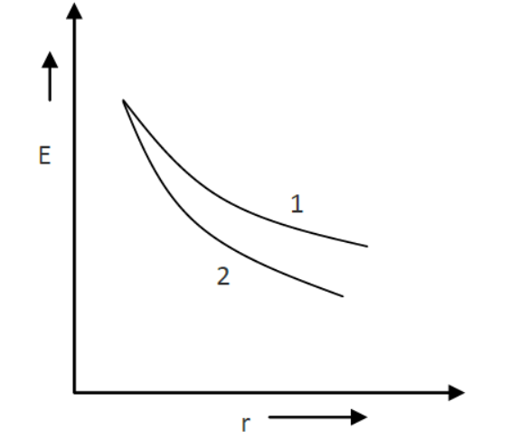

3. Draw Electric field lines for
I. Charge q>0
II. q<0
III. Two equal & opposite charges.
IV. Two equal & similar charges.
4. An electric dipole of length 10 cm having charges 6×10-3 C, placed at 30o w.r.t. a uniform electric field experiences a torque of magnitude 6 Nm. Calculate 3
a. magnitude of the electric field
b. the potential energy of the dipole
5. What is the potential energy of an isolated electric charge?
6. S1 and S2 are two hollow concentric spheres enclosing charges Q and 2Q respectively as shown in fig.
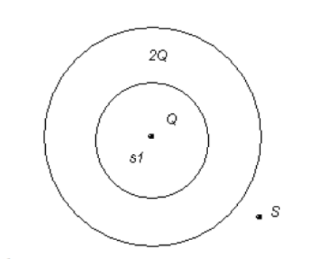

a. What is the ratio of electric flux through s1 and s2
b. How will the electric flux through the sphere s1 change, if a medium of dielectric constant 5 is introduced in the space inside s in place of air?
7. A cubical surface encloses a charge of 8.85x10-8C
a. Calculate the electric flux through one face of the cube.
b. If the charge is enclosed by a spherical surface of radius 7cm; what is the flux through the spherical surface?
8. If the electric field is given by 6i+3j+4k, calculate the electric flux through a surface of area 20 units lying in Y-Z plane.
9. Show graphically variation of electric field due to a charged conducting sphere with distance and briefly explain it.
10. Explain why the electric field inside a conductor placed in an external electric field is zero.
11. Two capacitors of capacitances 2μF and 2μF are connected first in series and then parallel. What is the ratio of their capacitances?
12. Calculate the equivalent capacitance between the points A and B in the combination shown below
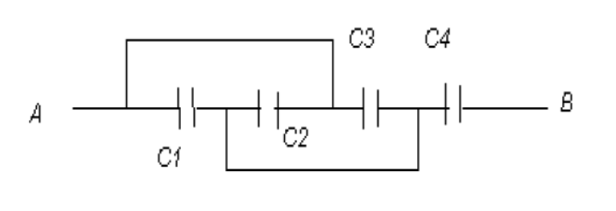

Given C1 = 5 F; C2= 10 F , C3= 15 F; C4= 30 F
13. A parallel plate capacitor with each plate of area A and separation d is charged to a potential difference V. The battery used to charge it is then disconnected. A dielectric slab of thickness d and dielectric constant k is now placed between the plates. What change if any, will take place in
a. Charge on plates?
b. Electric field intensity between the plates?
c. Capacitance of capacitor.
14. Two parallel plates PQ and RS are kept distance ‘d’ apart. Area of each plate is ‘A’. The space between them is filled with three dielectrics slab of identical size, having
dielectric constants k1, k2, and k3, respectively as shown below; find the capacitance of the capacitor.
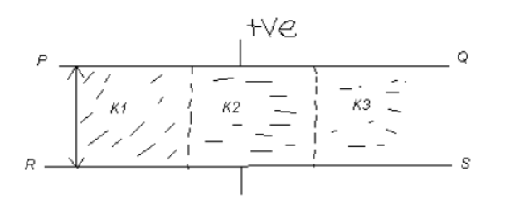

15. Two plates of a parallel plate capacitor are 0.01 metre apart. A dielectric slab of dielectric constant 6 and thickness 0.005m is introduced between the plates parallel to the plates of the capacitor. Determine the distance between the plates such that the capacitance remains the same after suitable adjustments of the plates.

NCERT exercise of chapter1 and Chapter 2

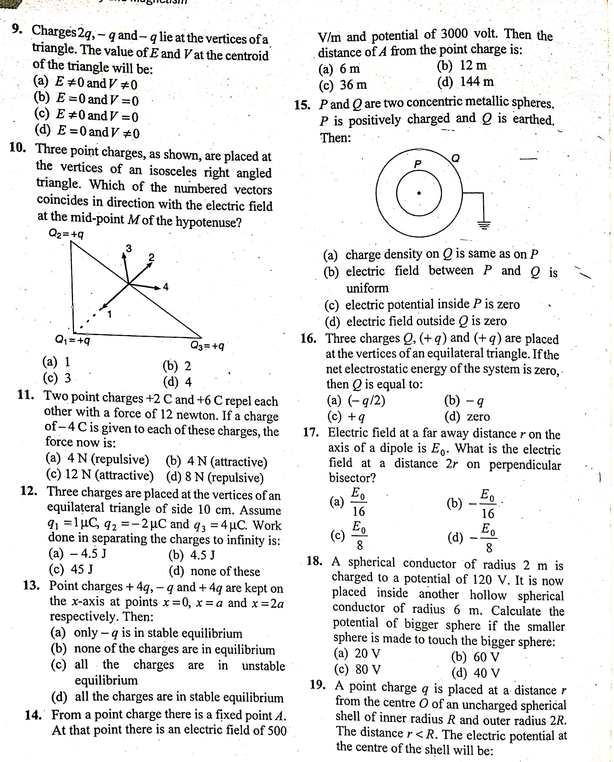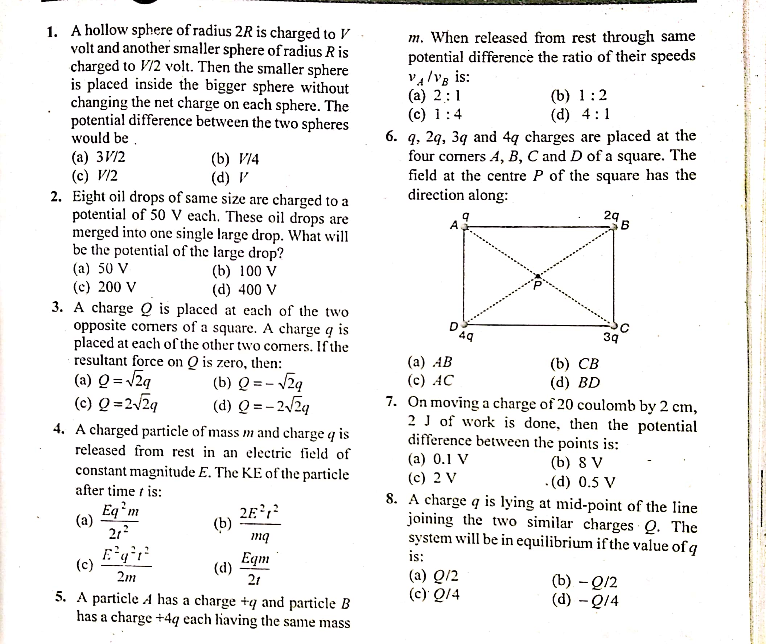

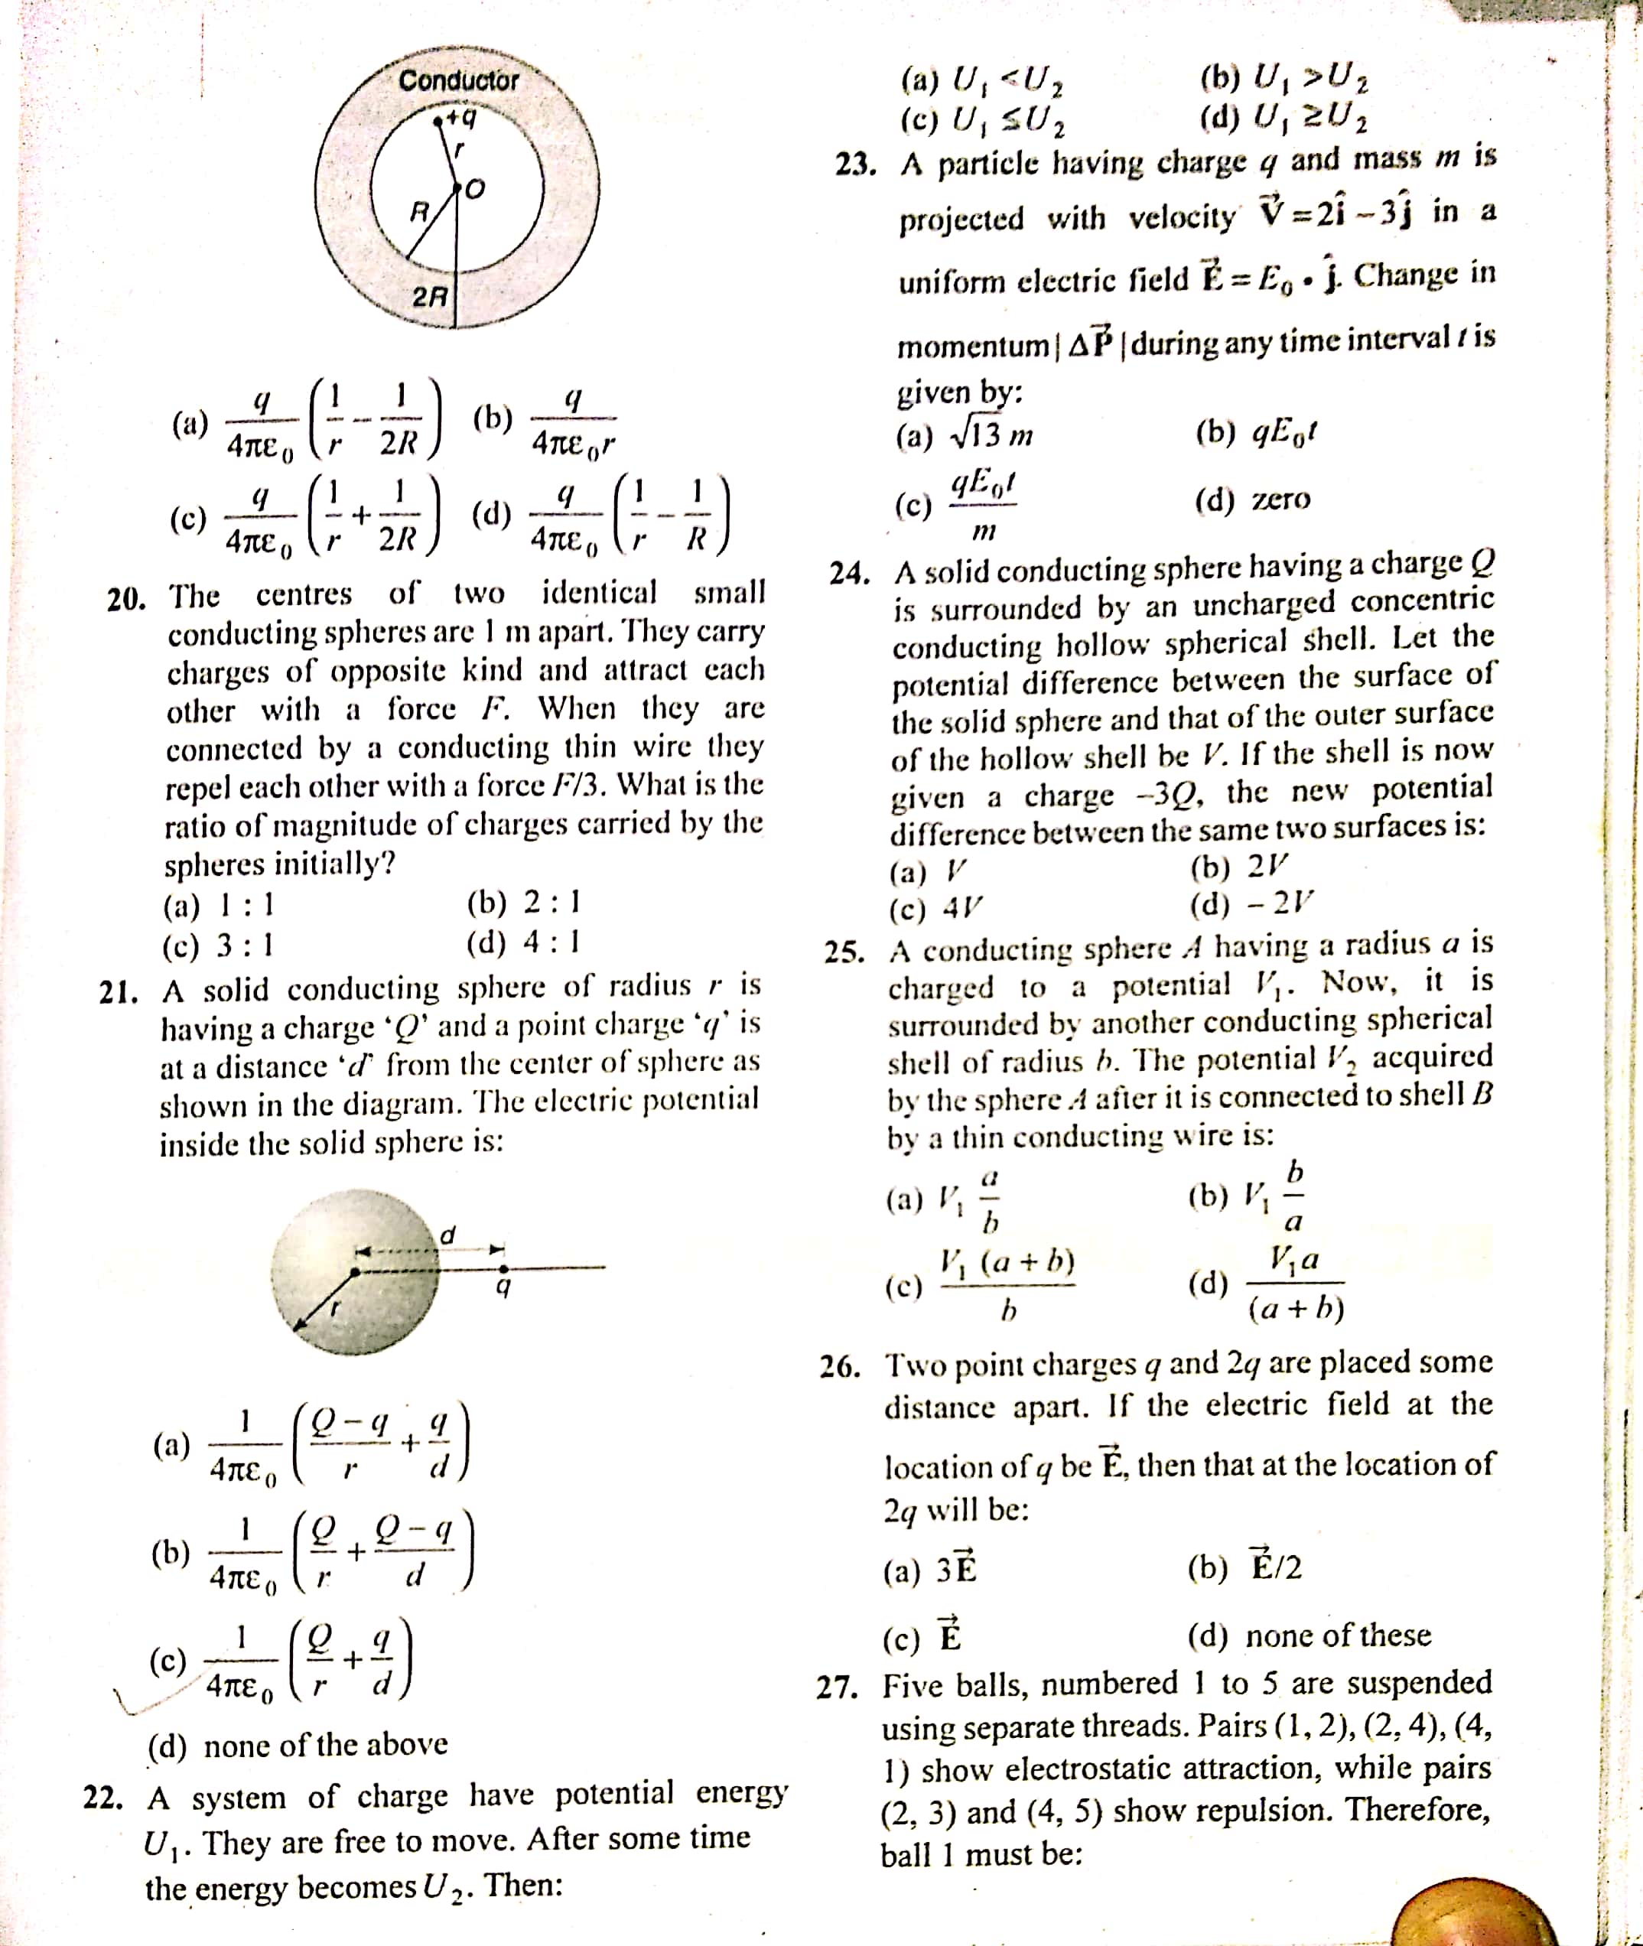
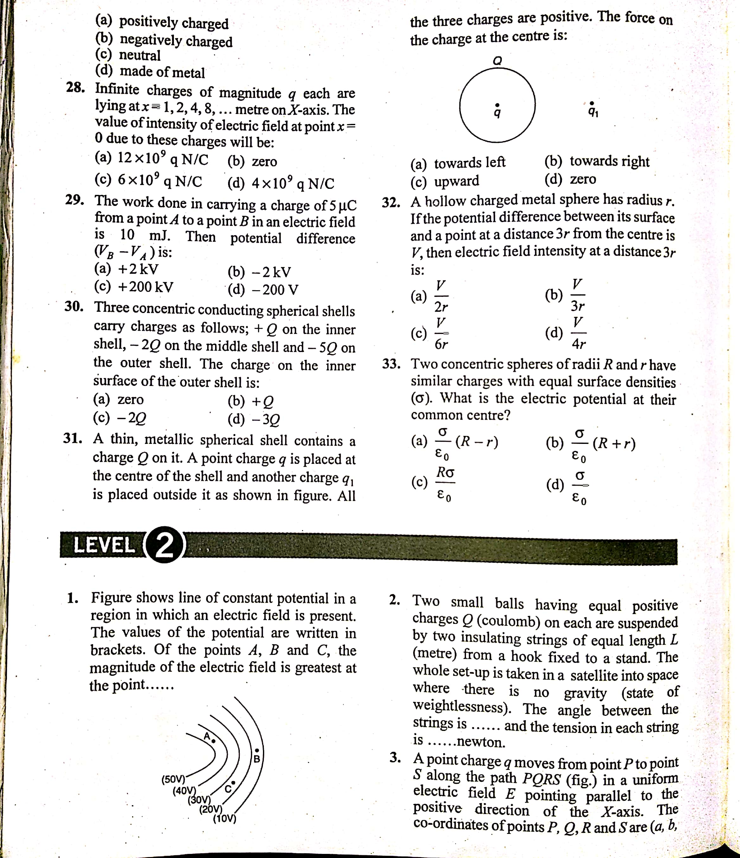
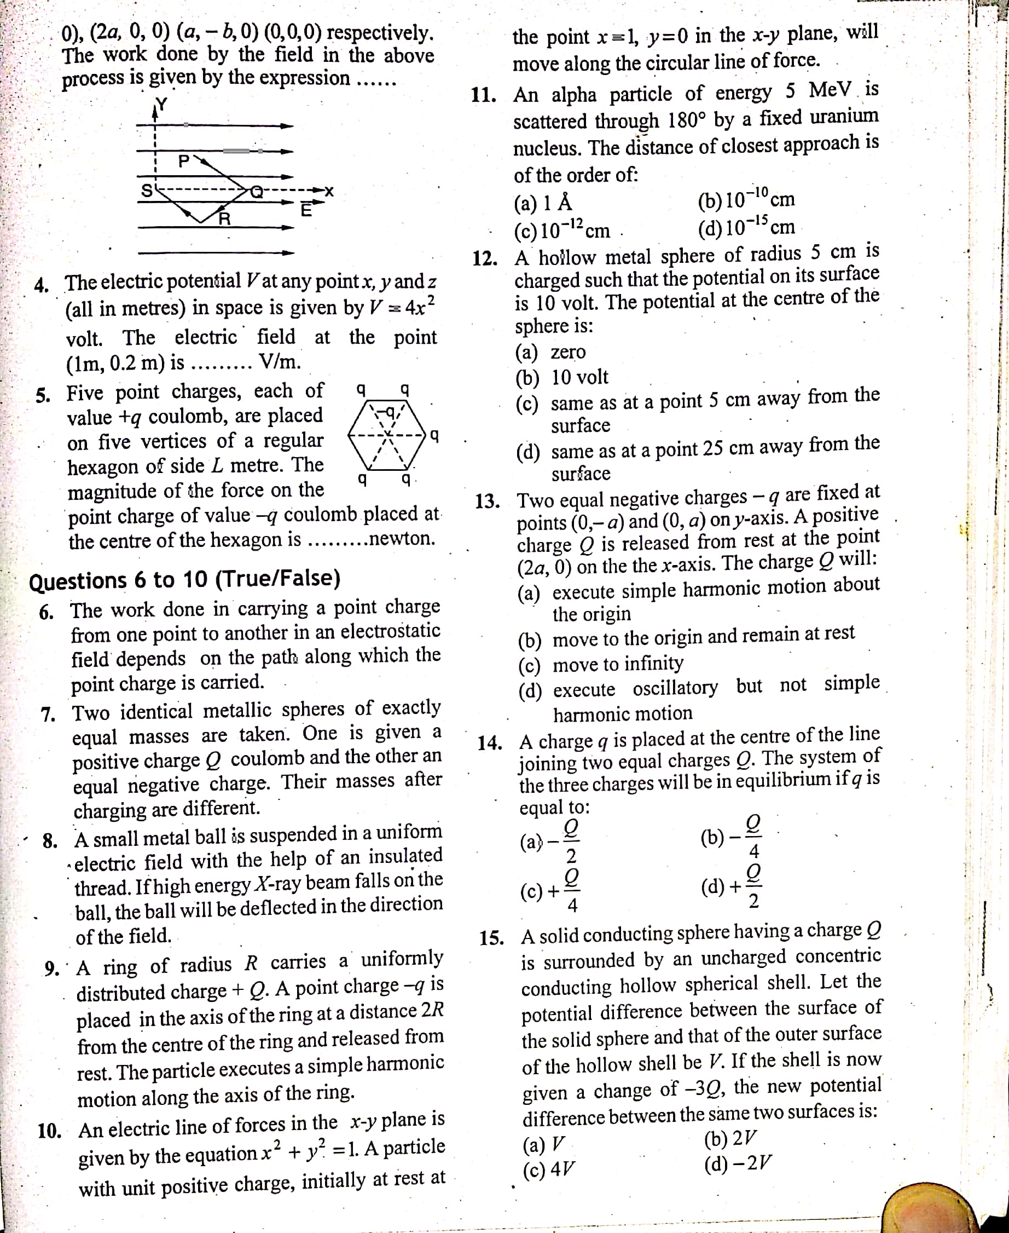

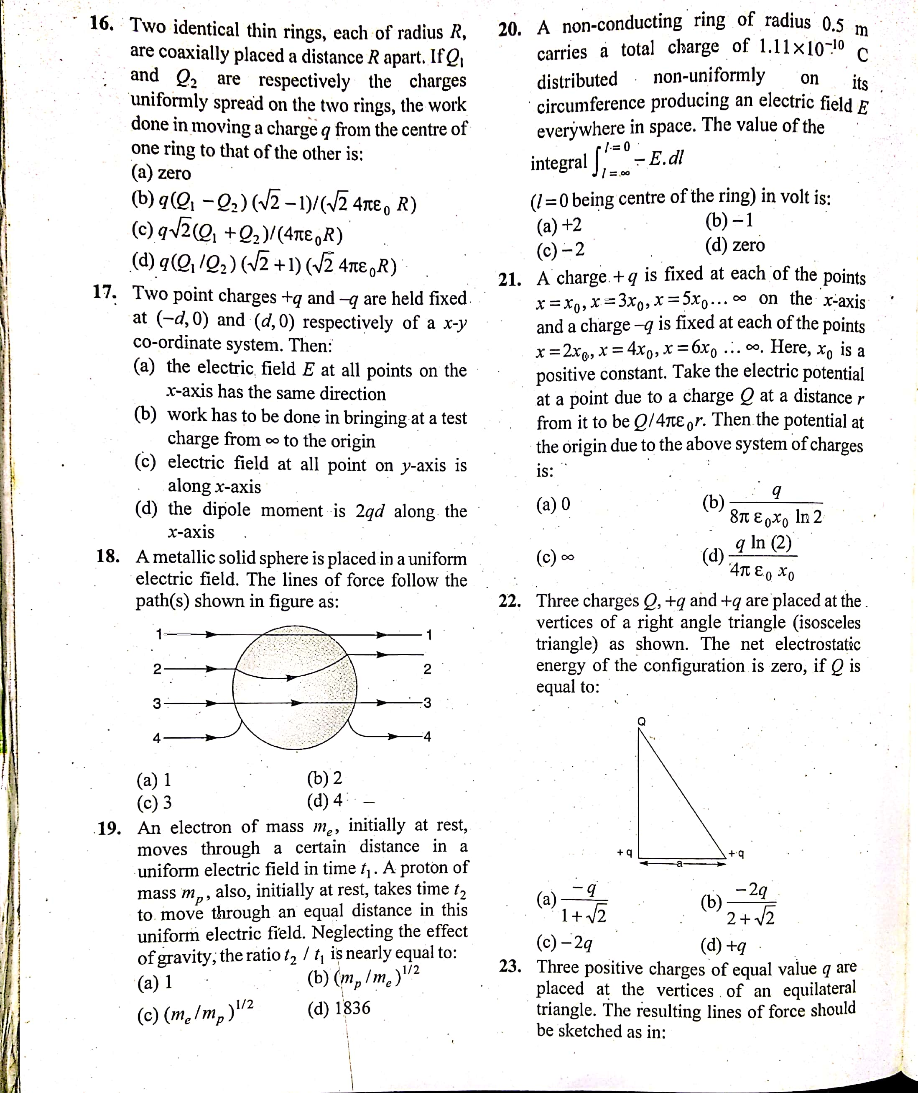

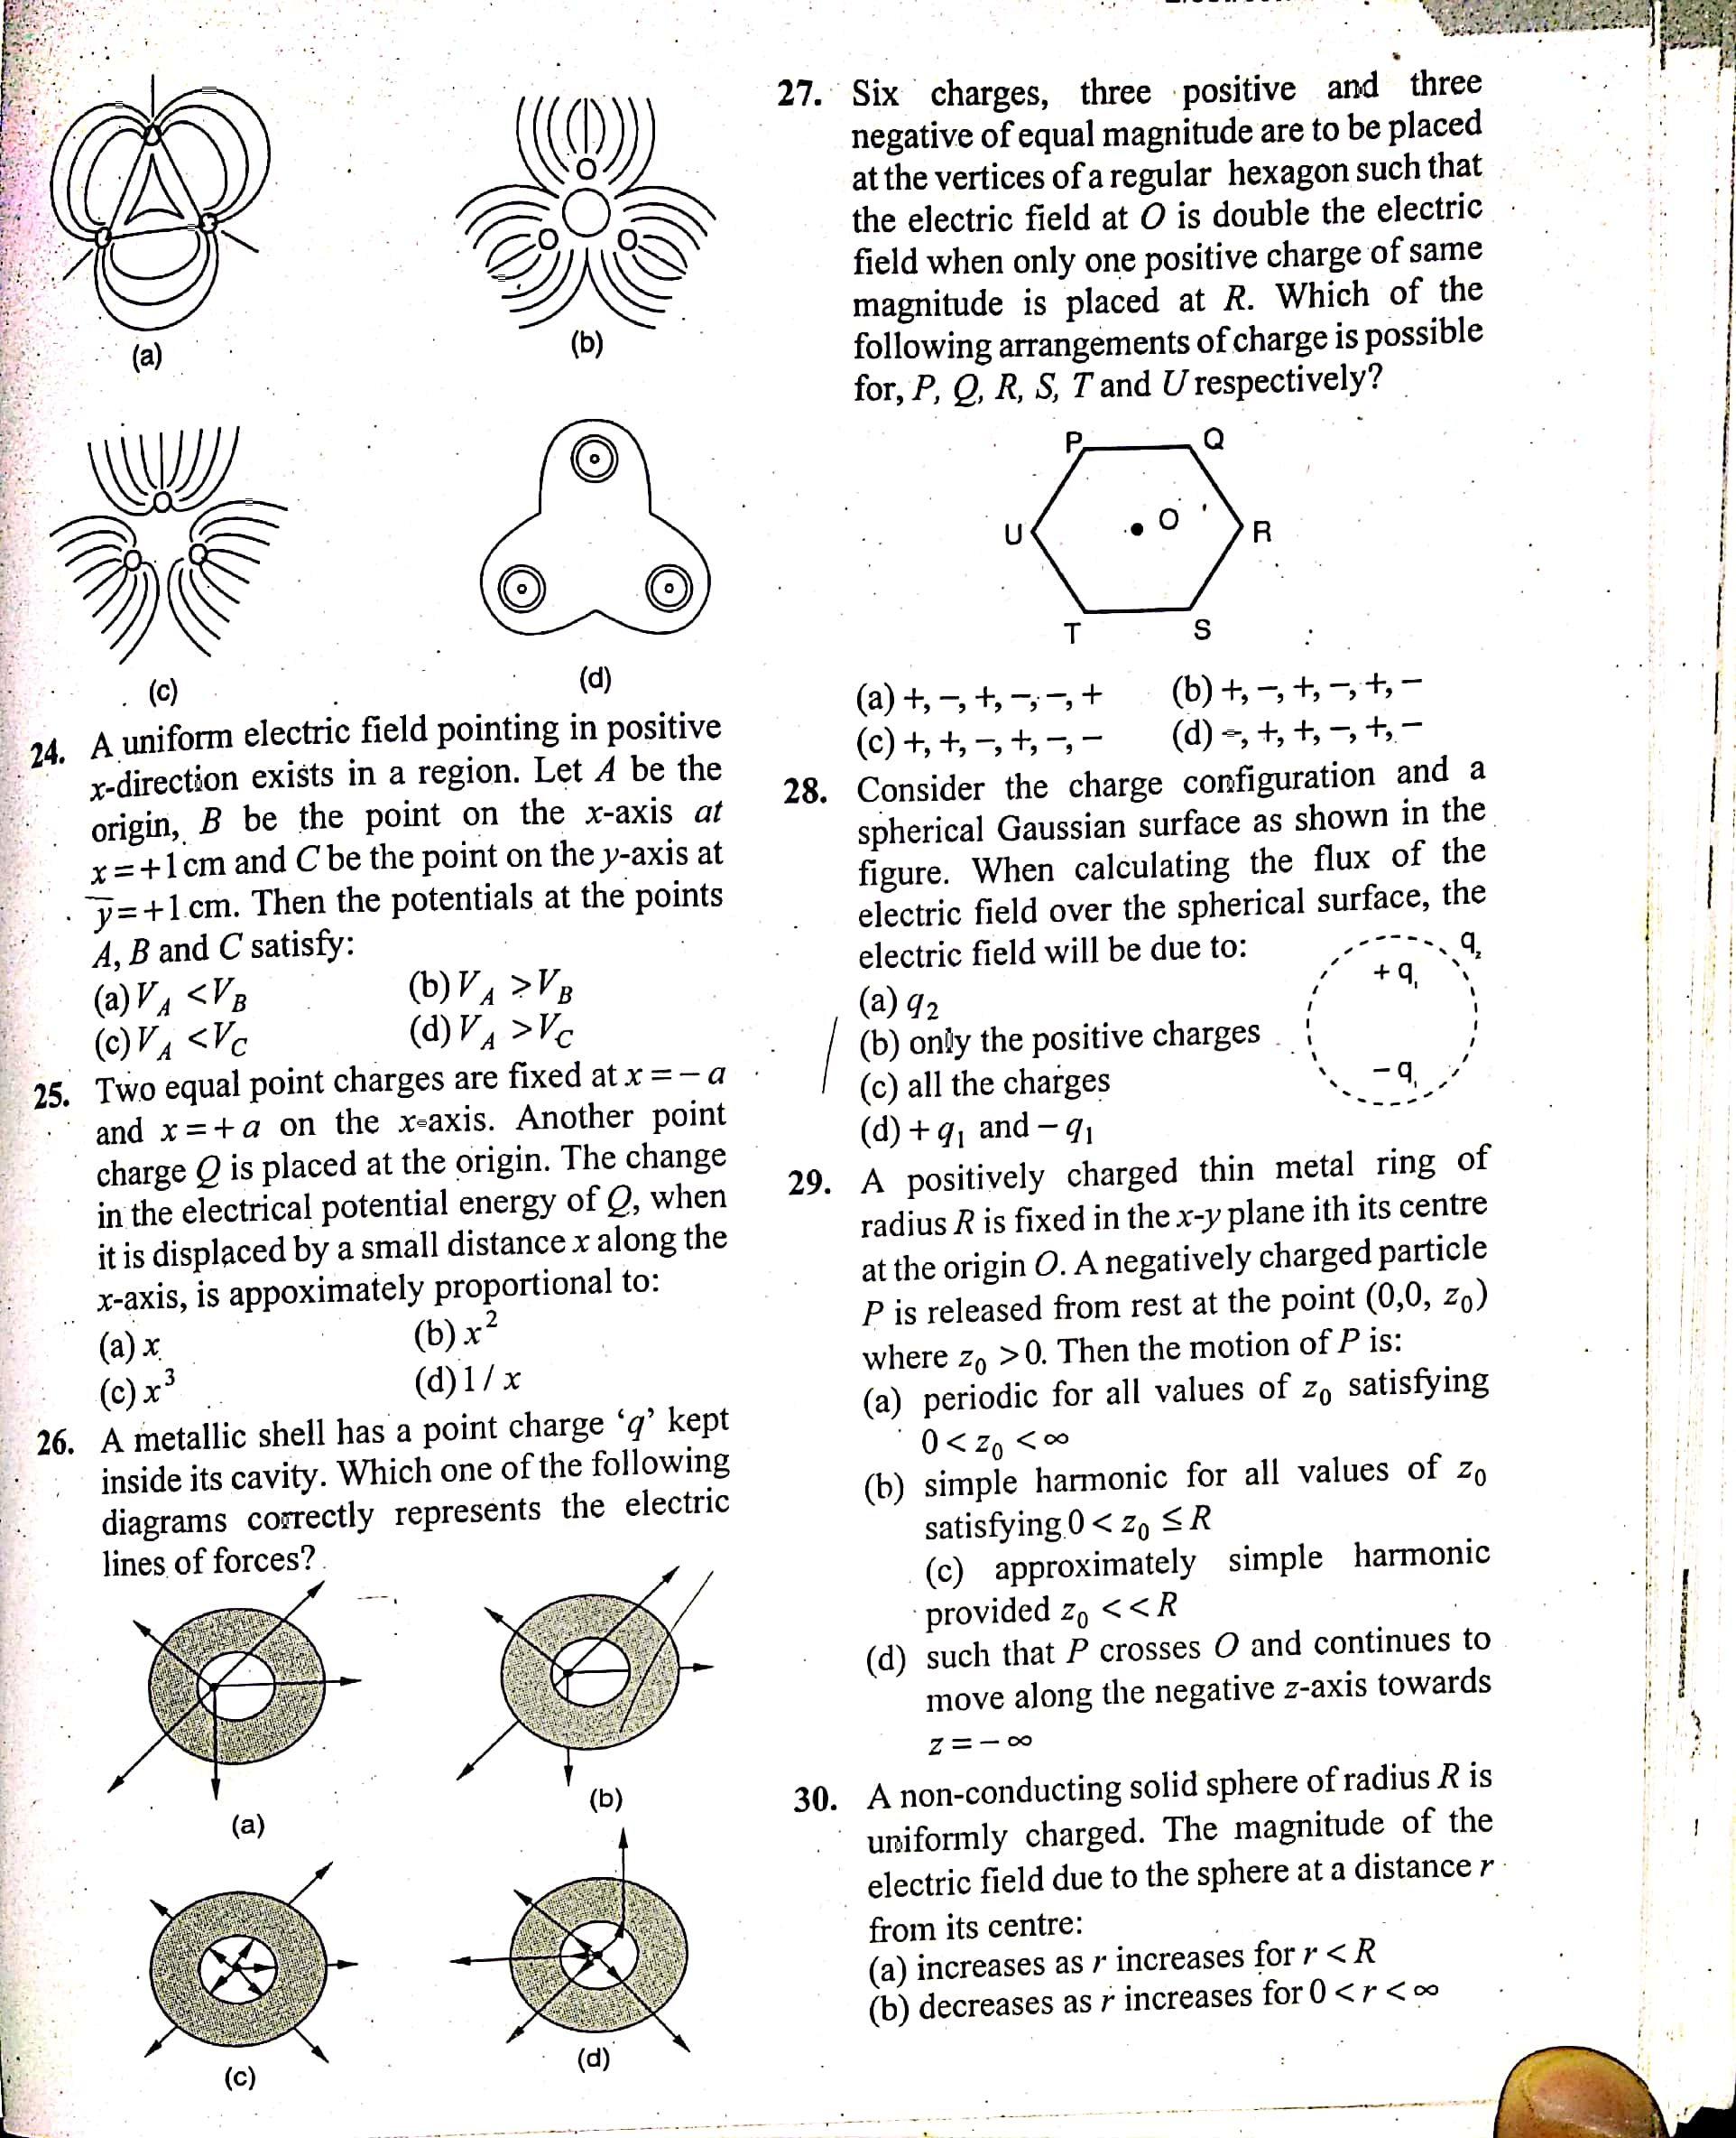

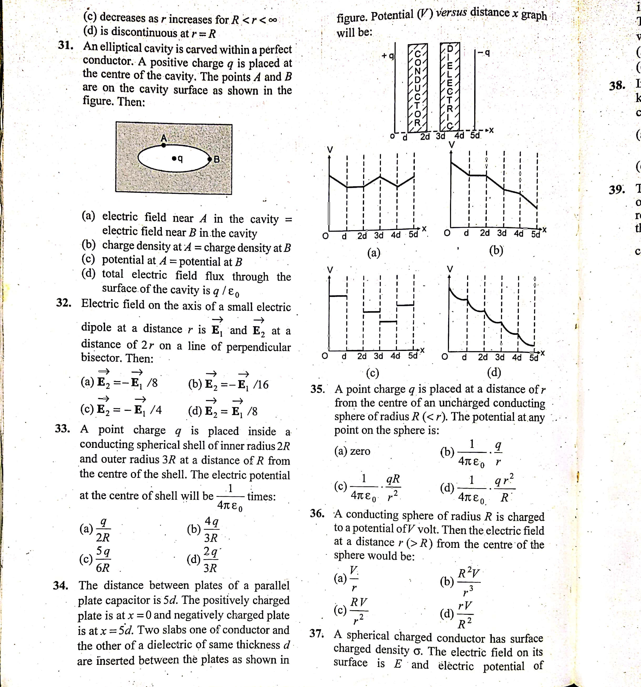

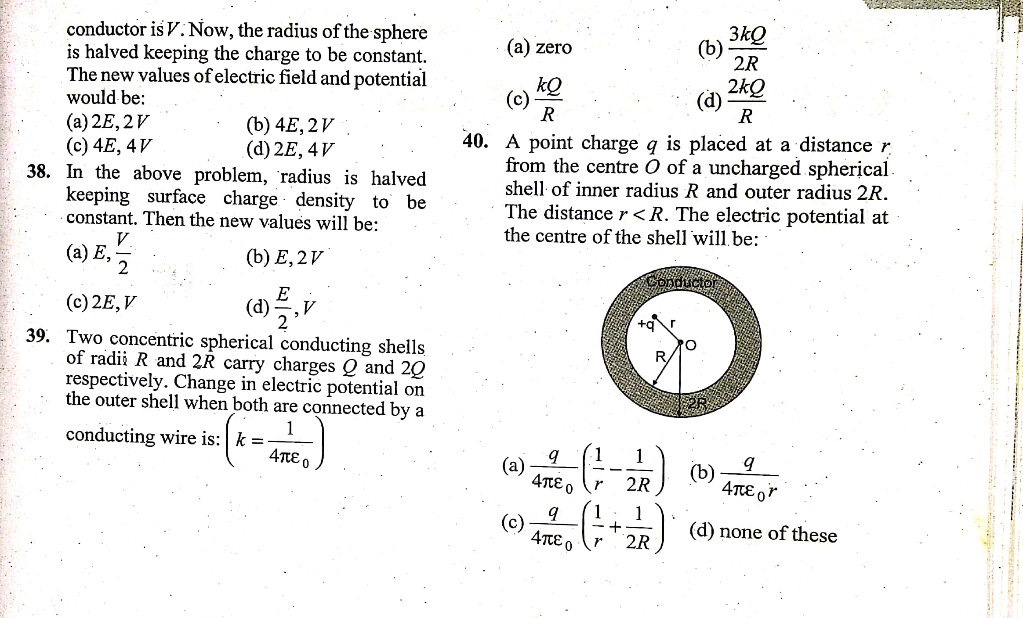

HOLIDAY HOMEWORK
CLASS XII-BIOLOGY
1. Choose the incorrect statement from the following:
a. In birds and mammals internal fertilisation takes place b. Colostrum
contains antibodies and nutrients c. Polyspermy is prevented by the
chemical changes in the egg surface d. In the human female implantation
occurs almost seven days after
fertilisation
2. Identify the wrong statement from the following:
a. High levels of estrogen triggers the ovulatory surge. b. Orgonial cells
start to proliferate and give rise to functional ova in
regular cycles from puberty onwards. c. Sperms released from seminiferous
tubules are poorly motile /
non-motile. d. Progesterone level is high during the post ovulatory phase of
menstrual cycle.
3. Spot the odd one out from the following structures with reference to the
male reproductive system:
a. Rete testis b. Epididymis c. Vasa efferentia d. Isthmus
4. Seminal plasma, the fluid part of semen, is contributed by.
i. Seminal vesicle ii. Prostate iii. Urethra iv. Bulbourethral gland
(a) i and ii (b) i, ii and iv (c) ii, iii and iv (d) i and iv
5. Spermiation is the process of the release of sperms from:
a. Seminiferous tubules b. Vas deferens c. Epididymis d. Prostate gland
6. Mature Graafian follicle is generally present in the ovary of a healthy
human female around stet:
a. 5 – 8 day of menstrual cycle b. 11 – 17 day of menstrual cycle c. 18 – 23
day of menstrual cycle d. 24 – 28 day of menstrual cycle
7. Acrosomal reaction of the sperm occurs due to:
a. Its contact with zona pellucida of the ova b. Reactions within the uterine
environment of the female c. Reactions within the epididymal environment
of the male d. Androgens produced in the uterus
8. Which one of the following is not a male accessory gland?
a. Seminal vesicle b. Ampulla c. Prostate d. Bulbourethral gland
9. The immature male germ cell undergo division to produce sperms by the
process of spermatogenesis. Choose the correct one with reference to
above. a. Spermatogonia have 46 chromosomes and always undergo
meiotic
cell division b. Primary spermatocytes divide by mitotic cell division c.
Secondary spermatocytes have 23 chromosomes and undergo
second meiotic division d. Spermatozoa are transformed into spermatids
10. Match between the following representing parts of the sperm and their
functions and choose the correct option.
Col. A Col. B A. Head i. Enzymes B. Middle piece ii. Sperm motility C.
Acrosome iii. Energy D. Tail iv. Genetic material
options:
a. A-ii, B-iv, C-i, D-iii b. A-iv, B-iii,
C-i, D-ii c. A-iv, B-i, C-ii,
D-iii d. A-ii, B-i, C-iii, D-iv
11. Which among the following has 23 chromosomes?
a. Spermatogonia b. Zygote c.
Secondary oöcyte d.
Oögonia
12. Match the following and choose the correct options:
A. Trophoblast i. Embedding of blastocyst in the endome
trium B. Cleavage ii. Group of cells that would differentiate
as embryo C. Inner cell mass iii. Outer layer of blastocyst attached to the
endometrium D. Implantation iv. Mitotic division of zygote Options: a.
A-ii, B-i, C-iii, D-iv b. A-iii, B-iv, C-ii, D-i c. A-iii, B-i, C-ii, D-iv d. A-ii, B-iv,
C-iii, D-i
13. Which of the following hormones is not secreted by human placenta?
a. hCG b. Estrogens c. Progesterone d. LH
14. The vas deferens receives duct from the seminal vesicle and opens into
urethra as:
a. Epididymis b. Ejaculatory duct c. Efferent ductule d. Ureter
15. Urethral meatus refers to the:
a. Urinogenital duct b. Opening of vas deferens into urethra c. External opening
of the urinogenital duct d. Muscles surrounding the
urinogenial duct
16. Morula is a developmental stage:
a. Between the zygote and blastocyst b. Between the blastocyst and gastrula c.
After the implantation d. Between implantation and
parturition
17. The membranous cover of the ovum at ovulation is:
a. Corona radiata b. Zona radiata c. Zona pellucida d. Chorion
18. Identify the odd one from the following:
a. Labia minora b. Fimbriae c. Infundibulum d. Isthmus
VERY SHORT ANSWER TYPE QUESTIONS
1. Given below are the events in human reproduction. Write them in correct
sequential order.
Insemination, gametogenesis, fertilisation, parturition, gestation, implantation
2. The path of sperm transport is given below. Provide the missing steps in
blank boxes.
3. What is the role of cervix in the human female reproductive system?
4. Why are menstrual cycles absent during pregnancy.
5. Female reproductive organs and associated functions are given below
in column A and B. Fill the blank boxes.
6. From where the parturition signals arise-mother or foetus? Mention the
main hormone involved in parturition.
7. What is the significance of epididymis in male fertility?
8. Give the names and functions of the hormones involved in the process of
spermatogenesis. Write the names of the endocrine glands from where they are
released.
9. The mother germ cells are transformed into a mature follicle through
series of steps. Provide the missing steps in the blank boxes.
10. During reproduction, the chromosome number (2n) reduces to half (n) in the
gametes and again the original number (2n) is restored in the offspring,
What are the processes through which these events take place?
11. What is the difference between a primary oöcyte and a secondary oöcyte?
12. What is the significance of ampullary–isthmic junction in the female
reproductive tract?
13. How does zona pellucida of ovum help in preventing polyspermy?
14. Mention the importance of LH surge during menstrual cycle.
15. Which type of cell division forms spermatids from the secondary
spermatocytes?
SHORT ANSWER TYPE QUESTIONS
1. A human female experiences two major changes, menarche and menopause
during her life. Mention the significance of both the events.
2. a. How many spermatozoa are formed from one secondary
spermatocyte? b. Where does the first cleavage division of zygote take place?
3. Corpus luteum in pregnancy has a long life. However, if fertilisation does
not take place, it remains active only for 10-12 days. Explain.
4. What is foetal ejection reflex? Explain how it leads to parturition?
5. Except endocrine function, what are the other functions of placenta.
6. Why doctors recommend breast feeding during initial period of infant
growth?
7. What are the events that take place in the ovary and uterus during
follicular phase of the menstrual cycle.
8. Given below is a flow chart showing ovarian changes during menstrual cycle.
Fill in the spaces giving the name of the hormones responsible
for the events shown.
9. Give a schematic labelled diagram to represent oögenesis (without
descriptions)
10. What are the changes in the oogonia during the transition of a primary
follicle to Graafian follicle?
LONG ANSWER QUESTIONS
1. What role does pituitary gonadotropins play during follicular and ovulatory
phases of menstrual cycle? Explain the shifts in steroidal
secretions.
2. Meiotic division during oogenesis is different from that in
spermatogenesis. Explain how and why?
3. The zygote passes through several developmental stages till implantation,
Describe each stage briefly with suitable diagrams.
4. Draw a neat diagram of the female reproductive system and label the parts
associated with the following (a) production of gamete, (b) site of fertilisation (c) site of
implantation and, (d) birth canal.
- With a suitable diagram, describe the organisation of mammary gland.

- dsUnzh; fon~;ky; dk”khiqj
- 05-05-2020
- xzh’e dkyhu ¼vodk”k½ x`g dk;Z
- d{kk & 12
- fo’k; & fgUnh dsfUnzd
-  vc rd ohfM;ks }kjk i<+kbZ x;h dforkvksa ds ohfM;ks esa fn;s x;s iz”u ,oa lHkh dk;Zi=dksa esa fn;s x;s iz”uksa ds mRrj fy[ksaA

-  rqylhnkl dh dfork ds “ks’k Hkkx dh fofM;ks esa fn;s x;s iz”u] fQ+jkd xksj[kiqjh ,oa mek”kadj tks”kh dh dforkvksa ds fofM;ks dks ns[kdj mlesa fn;s x;s iz”uksa ds mRrj fy[ksaA

-  fuEufyf[kr fo’k; ij Qh+pj fy[ksa &

- Þeksckby [krjs dh ?kaVhß
- Þofj’B ukxfjdksa dh leL;k,aß
- ÞLoPN Hkkjr] LoLFk Hkkjrß
-  fuEufyf[kr fo’k;ksa ij vkys[k fy[ksa &

- Þlkekftd ewY;ksa dk ladVß
- Þxkaoksa esa QSyrk QS”kuß
- ÞcM+s “kgjksa esa thou dh pqukSfr;k¡ß
-  fuEufyf[kr fo’k; ij fuca/k fy[ksa &

- Þdksjksuk ok;jl% ,d egkekjhß
-  *vfHkO;fDr vkSj ek/;e* iqLrd ds izFke pkj ikBksa ds iz”uksa ds mRrj fy[ksaA

