Kendriya Vidyalaya Kashipur
Holidays Home Work
Economics Class-XII

National Income
Q.1 How will you treat the following while calculating national income, give reason
i) Income earn from sale of shares.
ii) Income earn from sale of second hand car.
iii) Bonus received from employer.
iv) Profit earn by Amazon in India.
v) Commission received on sale of a house.
vi) Expenditure on advertisement by a firm.
vii) Scholarship given to students.
viii) Income obtained from gambling.
ix) Interest received by a household from bank
x) Profit earned by Indian company in Singapore
Q.2. Calculate National income by (a) Income Method and (b) Expenditure Method:
Items (Rupees in Crores)

- Rent 3,000
- Net factor income from abroad 100
- Wages and salary 50,000
- Indirect tax 2,000
- Govt Final Consumption Expenditure 22,400
- Subsidy 600
- Royalty 400
- Net exports (-) 400
- Interest 12,800
- Corporate tax 400
- Profit after tax 8,000
- Private Final Consumption Expenditure 52,600
- Change in stock 200
- Net Domestic Fixed Capital Formation 1200

3. Calculate National income by (a) Income Method and (b) Expenditure Method:
Items (Rupees in Crores)

- Rent 3,000
- Net factor income from abroad 100
- Wages and salary 50,000
- Indirect tax 2,000
- Govt Final Consumption Expenditure 22,400
- Subsidy 600
- Royalty 400
- Net exports (-) 400
- Interest 12,800
- Corporate tax 400
- Profit after tax 8,000
- Private Final Consumption Expenditure 52,600
- Change in stock 200
- Net Domestic Fixed Capital Formation 1200

4-Find (a) National Income and (b) GDP at market price
Items Rs Crore
- Net current transfer from abroad 5
- Private final consumption expenditure 200
- Subsidies 20
- Net domestic fixed capital formation 40
- Net factor income to abroad 10
- Government final consumption expenditure 50
- Change in stock (-)10
- Net imports (-)20
- Consumption of fixed capital 30
- Indirect tax 60
- Exports 100

5- Calculate gross National Product at market price from the following data ( values are in crors)
Compensation of employees 4000
Rent 800
Profits 1500
Undistributed profits 400
Mixed income of self-employed 1800
Net export - 30
Net domestic capital formation 900
Gross domestic fixed capital formation 1000
Change in stock -80
Interest 50
NIT 900
Net current transfer from abroad 500
Net factor income from abroad 60

6-From the following data, calculate National Product at Market Price by
(i) income method and (ii) expenditure method:
Items (Rs.In Crores)
a. Mixed income of self- employed 400
b. Compensation of employees 500
c. Private final consumption expenditure 900
d. Net factor income from abroad (-) 20
e. Net indirect tax 100
f. Consumption of fixed capital 100
g. Net domestic capital formation 280
h. Net exports (-)30
i. Profits 350
j. Rent 100
k. Interest 150
l. Government final consumption expenditure 450

7- Will the following be included in National Income of India? Give reasons for your answer.
a. Financial help given to flood victims
b. Profits earned by an Indian bank from its branches abroad.
c. Salaries paid to non-resident Indians working in Indian Embassy in America.

Q8 | Calculate National Income by income and expenditure method.  Particulars In crore  1. Compensation of employee 250  2. Imports 20  3. Mixed income of self employed 50  4. Gross fixed capital formation 120  5. Private final consumption expenditure 550  6. consumption of fixed capital 10  7. Net factor income from abroad 20  8. Indirect taxes 100  9. Change in stock 20  10. subsidies 20  11. Rent 100  12. Interest 200  13. Profit 50  14. Exports 10  15.Government final consumption expenditure 60  From the following data, calculate (a) gross domestic product at market price and (b) subsidies.  Particulars In crore  1. Government final consumption expenditure 7000  2. Indirect taxes 9000  3.NNP_{FC} 61700  4. Mixed income of self employed 28000  5. Gross fixed capital formation 13000  6. Net addition to stocks 10000  7. Compensation to employee 24000  8. Depreciation 4000  9. Private final consumption expenditure 44000  10. Export of goods and services 11. Import of goods and services 12.NFIA 4800 5600 -300
Q9 Calculate Gross Domestic Product at Market Price by (6)

  - Production Method and (b) Income Method

ITEMS Rs. crores
- Intermediate consumption by

i) Primary sector |  | 500
ii) | Secondary sector | 400
iii) | Tertiary sector | 400
- Value of output by
 | i) Primary sector |  | 1000
 | ii) | Secondary sector | 900
 | iii) | Tertiary sector | 700
c. | Rent |  | 10
d. | compensation of employees |  | 400
e. | Mixed income |  | 550
f. | Operating surplus |  | 300
h. | Net factor income from abroad |  | (--)20
i. | Interest |  | 5
j. | Consumption of fixed capital |  | 40
k. | Net indirect taxes |  | 10

10 . Calculate the value of intermediate consumption from the following information:
Particulars In Rs crore
i. Net value added at factor cost 100
ii. Sales tax 20
iii. Depreciation। 10
iv. Value of output. 300
v. Subsidy 10

11- Find the value added at market price:
S. No. Items. Amount (Rs)
- Depreciation 800
ii. Output sold 900 units
iii. Price per unit of output 40
iv. Closing stock 1,000
v. Opening stocks 800
vi. Sales tax 3,000
vii. Intermediate cost 20,000
12-. Calculate GDP at factor cost from the following information:
i. Net domestic capital formation 100
ii. Change in stock 20
iii. Private final consumption expenditure 500
iv. Government final consumption expenditure 500
v. Net exports 30
vi. Consumption of fixed capital 10
vii. Net indirect taxes 150
viii. Net factor income from abroad 30
13- Calculate national income from the following data using income and expenditure method.
S.No. Items (Rs. InCrores)
1 Private final consumption expenditure 200
2 Subsidies 30
3 Net income from abroad (-) 20
4 Indirect tax 40
5 Rent 5
6 Govt. final consumption expenditure 40
7 Operating surplus 10
8 Net domestic fixed capital formation 10
9 Wages and salary 70
10 Net export 10
11 Change in stock 10
12 Employer’s social security contribution 20
13 Mixed income 130

14- From the following data calculate gross value added at factor cost.
Items | Rs. In lakhs
Net indirect taxes | 20
Purchase of intermediate products | 120
Purchase of machines | 300
Sales | 250
Consumption of fixed capital | 20
Change in stock | 30

15- From the following data estimate (a)Net indirect taxes and (b) NDP at FC
Item | Rs. crore
1.NNPatMP | 1400
2.NFIA | -20
3.GNPat FC | 1300
4.Depreciation | 100
5.National debt interest | 18

Money and Banking
16 Explain the following functions of central bank
- Issue of Currency
- Lender of the last resort
- Bankers bank
- Government’s bank

17- Explain the process of credit creation by using following example
- Initial Deposit- 5000 LRR= 10%
- Initial Deposit- 50000 LRR= 20%
- Initial Deposit- 100000 LRR= 25%

18- How do central bank control supply of money in the economy by using following instrument
- CRR b) Open Market Operation c) Repo rate d) Reverse Repo rate e) Margin Requirement

KENDRIYA VIDYALAYA KASHIPUR
HOME ASSIGNMENT FOR SUMMER VACATION
CLASS- 12TH
SUBJECT- ENGLISH
(READING)
- READING OF FOLLOWING LESSONS AND SOLVING COMPREHENSION EXERCISES GIVEN ALONG WITH THE TEXT:
- Last Lesson (Flamingo)
- Lost Spring (Flamingo)
- My Mother At Sixty Six (Flamingo)
- An Elementary school classroom in a slum (Flamingo)
- Third Level ( vistas)
- Tiger king ( vistas)
NOTE :- All this work must be completed in a Ax4 size fair notebook.
(WRITING)
- WRITE ALL THESE QUESTIONS IN PROPER FORMAT AND WORD LIMIT(120 TO 150 WORDS):
- Write a letter to the editor of a national daily, highlighting the problem of CORONA and unhygienic public places and suggesting practical ways to ensure public sanitation to save people from diseases.
- You are Neha/Nihal, computer in-charge of Army Public School, New Delhi. Your school wishes to buy 20 computers and computer accessories from Apple Inc., Nehru Place, New Delhi. Draft a letter placing an order for the same.(100-150 words)
- You are RAM/RAJNI, 48-drona vihar,kashipur. Draft a classified advertisement, in not more than 50 words to sell your house giving all necessary detail.
- You are Sonali, cultural captain,Army Public School,Haldwani. Writ a notice for the school noticeboard informing the students about RANGOLI COMPETETION in the school.
NOTE :- 1. All this work must be completed in an Ax4 size fair notebook.
- For any help please visit youtube channel-htts://www.youtube.com/channel/UCILNx9AvR1KbE6_tuyRPMYg
Or www.yschandel.blogspot.com

KV KASHIPUR
CLASS:- XIIC, SUBJECT:- HISTORY :- SUMMER HOLIDAY HOMEWORK(2020-21)
Q1. Which are the probable religious features of the Harappans that have been found by archaeologists?
Q2. The major Harappan centre of craft production
Q3. Who authored the work Mudrarakshasam?
Q4 Who deciphered Brahmi script in 1838?
Q5 The archaeologist connected with Hastinapura excavation:
Q6.Who was kushana?
Q7.What was Agrahara?
Q8.Describe briefly the most distinctive feature of urban center of Harapan .
Q9. Describe the administrative features of the Mauryan Empire.
Q10. Explain why patriliny may have been particularly important among elite families.
Q11. “The problems of archaeological interpretation are perhaps most evident in attempts to reconstruct the religious practices of Harappa”. Give suitable arguments in support of your answer.
Q12. “There are limits to what epigraphy can reveal.” Justify with suitable arguments.
Q13. “Brahmanical norms regarding marriage and occupation were not universally followed in ancient times.” Give arguments in support of your answer.
Q14. ‘Historians find it particularly difficult task to understand a text as complex as the Mahabharata’. Justify the statement.
Q15. “Historians often try to understand the meaning of sculpture by comparing it with textual evidence.” Evaluate the statement in the context of Sanchi Stupa.
Q16. “The notion of a savior was not unique to Buddhism . The similar idea was being developed in different ways within traditions of Vaishnavism and Shaivism“ Examine the statement with suitable examples.
Q17.How were Harappa seals and sealings used to facilitate long distance communication?
Q18. Explain the system of land grant and trade from 600 BCE to 600 CE.
Q19. Describe the position of the untouchables in ancient society.
Q20. Critically examine the duties as laid down in ‘Manusmriti’ for the Chandalas.
MAP ACTIVITY:- Locate and label the following on the political outline map of India.
MAJOR BUDDHIST SITES:- Nagarjunakonda, Sanchi, Amaravati, Lumbini, Nasik, Bharhut, BodhGaya, Ajanta.

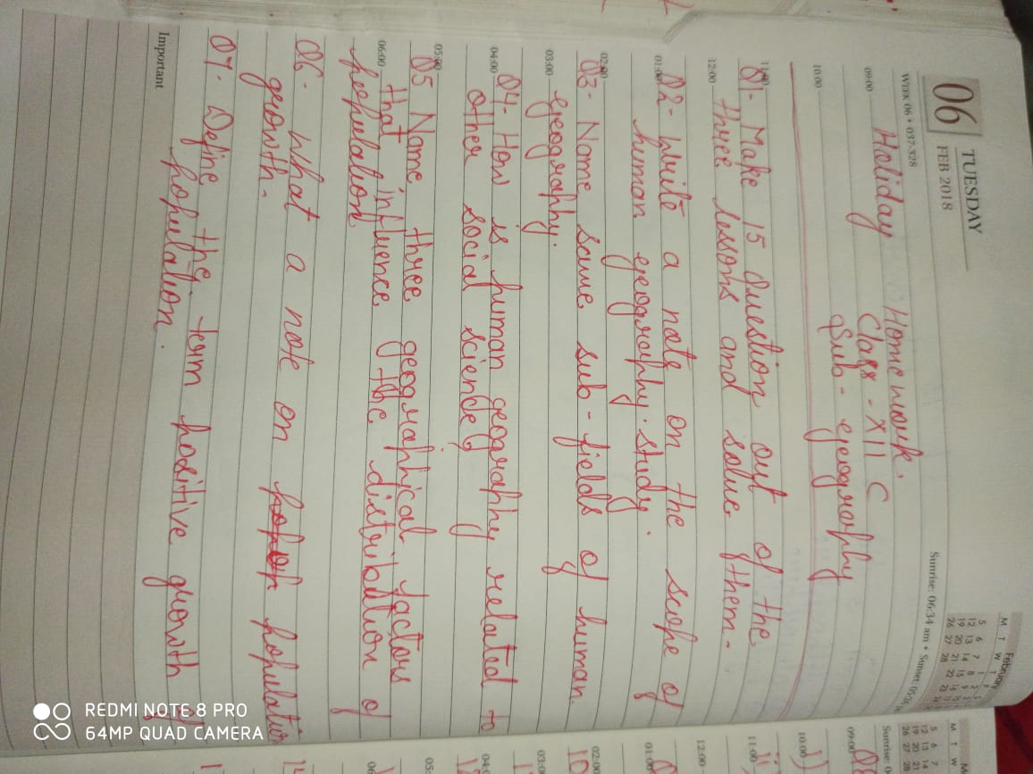

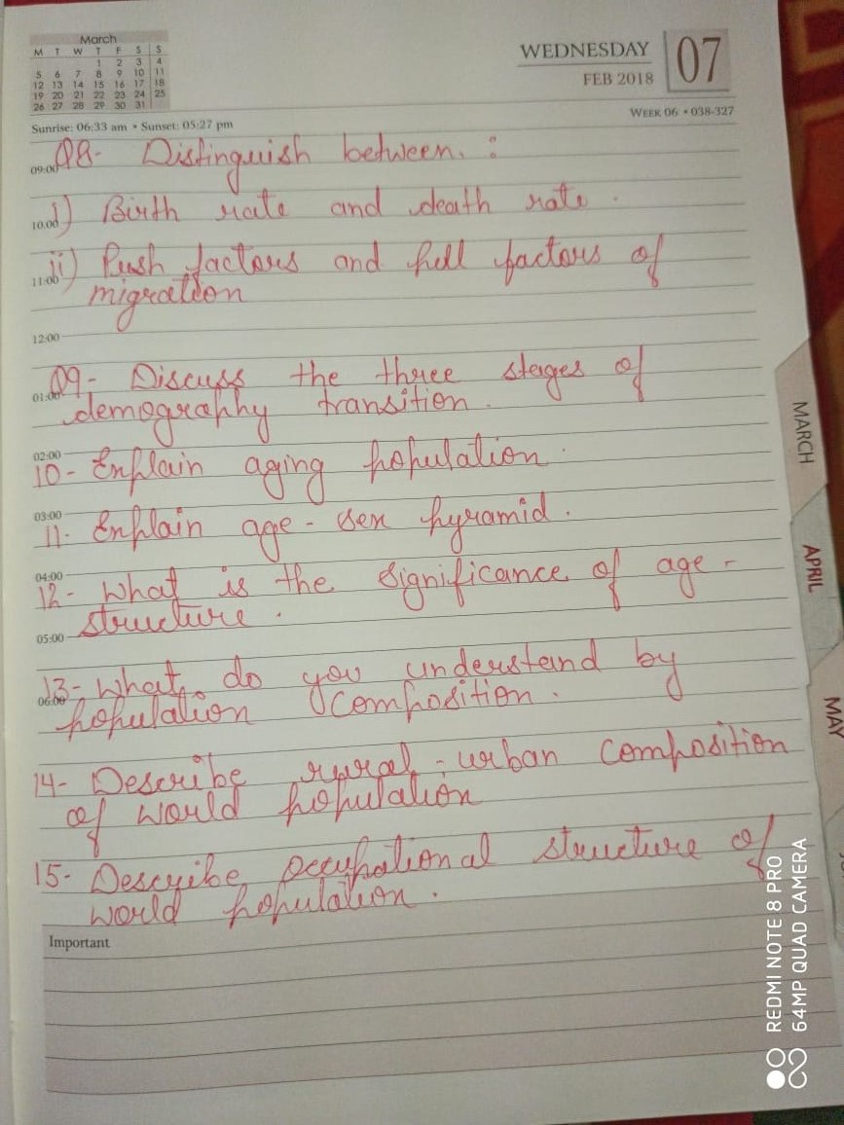

dsUnzh; fon~;ky; dk”khiqj
05-05-2020
xzh’e dkyhu ¼vodk”k½ x`g dk;Z
d{kk & 12
fo’k; & fgUnh dsfUnzd
 vc rd ohfM;ks }kjk i<+kbZ x;h dforkvksa ds ohfM;ks esa fn;s x;s iz”u ,oa lHkh dk;Zi=dksa esa fn;s x;s iz”uksa ds mRrj fy[ksaA

 rqylhnkl dh dfork ds “ks’k Hkkx dh fofM;ks esa fn;s x;s iz”u] fQ+jkd xksj[kiqjh ,oa mek”kadj tks”kh dh dforkvksa ds fofM;ks dks ns[kdj mlesa fn;s x;s iz”uksa ds mRrj fy[ksaA

 fuEufyf[kr fo’k; ij Qh+pj fy[ksa &

Þeksckby [krjs dh ?kaVhß
Þofj’B ukxfjdksa dh leL;k,aß
ÞLoPN Hkkjr] LoLFk Hkkjrß
 fuEufyf[kr fo’k;ksa ij vkys[k fy[ksa &

Þlkekftd ewY;ksa dk ladVß
Þxkaoksa esa QSyrk QS”kuß
ÞcM+s “kgjksa esa thou dh pqukSfr;k¡ß
 fuEufyf[kr fo’k; ij fuca/k fy[ksa &

Þdksjksuk ok;jl% ,d egkekjhß
 *vfHkO;fDr vkSj ek/;e* iqLrd ds izFke pkj ikBksa ds iz”uksa ds mRrj fy[ksaA

